***derskitabicevaplarim.comTHE 5th  GRADE***

***THE SIMPLE PRESENT TENSE***

1. ***POSITIVE FORM ( OLUMLU CÜMLE)***

***I***

***You***

***We LIKE***

***They***

***Theboys***

***( çoğul isim ) SWIMMING***

***He***

***She***

***It LIKES***

***The boy***

***Peter***

***(tekil isim)***

***EXERCISES***

1. ***Fill in theblankswiththesuitablewordsbelow***

***( speak / watch /go / fly/ drive / meet / ride / listen / read / do )***

***1) I like ------------ an experiment.***

***2) Shelikes ------------- to pop music.***

***3) Youlike -------------- English.***

***4) Theylike ------------- tothecinema.***

***5) Welike -------------- detectivefilms on T.V.***

***6) My fatherlikes --------------- a car.***

***7) Tomlikes ---------------- a kite.***

***8 ) I like ---------------myfriends at thecafe.***

***9) Mary likes ----------------- a book.***

***10) Bill likes --------------- his bicycle.***

***B) NEGATIVE FORM ( OLUMSUZ CÜMLE )***

***I***

***You***

***We***

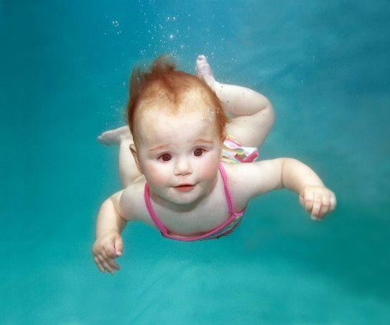***They DON’T LIKESWIMMING.***

***Theboys***

***( çoğul isim)***

***He***

***She***

***It DOESN’TLIKE SWIMMING***

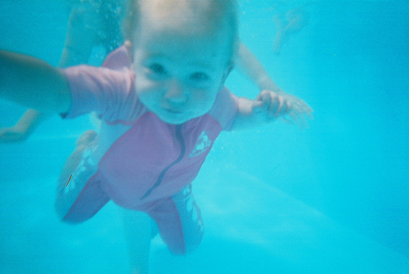 ***Peter***

***The boy***

***(tekil isim )***

***EXERCISES.***

***Fill in theblankswiththenegative form of theverbs***

***( wash / walk / clean/ eat/drink / visit/ draw/ watch / write /play )***

1. ***I -------- like ----------- coca-cola.***
2. ***He------- like ------------ his car.***
3. ***She------ like ------------- the board.***
4. ***You ----- like ------------- yourgrandparents on weekdays.***
5. ***We ----- like ------------ a letter.***
6. ***Thebaby ------- like ----------- hamburgers.***
7. ***They -------- like ------------- pictures.***
8. ***Mary -------- like ------------toschool.***
9. ***She --------- like ------------horrorfilms.***

***10)Helen ------- like ----------- football.***

***C) QUESTION FORM ( SORU CÜMLESİ )***

***I***

***You***

***DOWe***

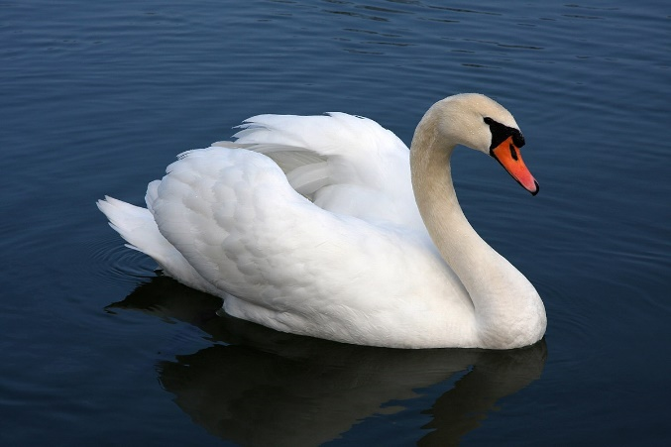 ***They***

***Theboys***

***( çoğul isim )***

***LIKE SWIMMING?***

***he***

***she***

***DOES it Peter The boy ( tekil isim )***

***EXERCISES***

***1) ------ youlike ----------- origami ? (do ) Yes,----------***

***2) -------shelove ----------hopscotch. ( play ) Yes, ---------***

***3)------- he hate ---------- stamps ? ( collect ) No,---------***

***4) ------ theyenjoy -------- a book ? ( read ) Yes, ------------***

***5) ------ Lindalike --------- ? (cook ) No, -------------***

***6) ------- a doglove ------- milk ? ( drink ) No, ------------***

***7 ) ------ thestudentslove -------- photos ? (take ) Yes, ------------***

derskitabicevaplarim.com ***Lütfiye TIN ELT.***