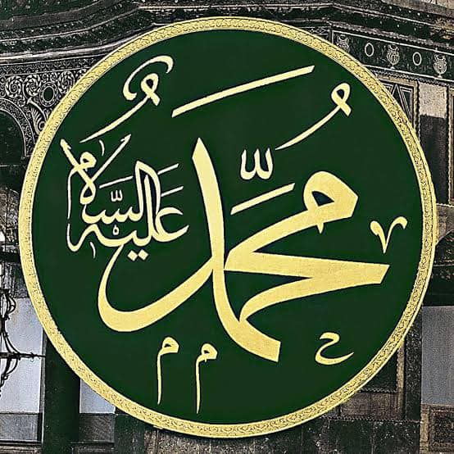

|  |  |  |  |  |  |  |  |  |  |  |  |  |  |  |  |  |  |  |  |  |  |  |  |
| --- | --- | --- | --- | --- | --- | --- | --- | --- | --- | --- | --- | --- | --- | --- | --- | --- | --- | --- | --- | --- | --- | --- | --- |
| M | U | H | A | M | M | E | D | M | U | H | A | M | M | E | D | M | U | H | A | M | M | E | D |
| A |  |  | A | H | M | E | D | A | H | M | E | D | A | H | M | E | D | A | H | M | E | D | M |
| H |  | A | H | M | E | D | A | H | M | E | D | A | H | M | E | D | A | H | M | E | D | A | U |
| M | A | H | M | E | D | A | H | M | E | D | A | H | M | E | D | A | H | M | E | D | A | H | S |
| U | H | M | E | D | A | H | M | E | D | A | H | M | E | D | A | H | M | E | D | A | H | M | T |
| D | M | E | D | A | H | M | E | D | A | H | M | E | D | A | H | M | E | D | A | H | M | E | A |
| M | E | D | A | H | M | E | D | A | H | M | E | D | A | H | M | E | D | A | H | M | E | D | F |
| A | D | A | H | M | E | D | A | H | M | E | D | A | H | M | E | D | A | H | M | E | D | A | A |
| H | A | H | M | E | D | A | H | M | E | D | A | H | M | E | D | A | H | M | E | D | A | H | M |
| M | H | M | E | D | A | H | M | E | D | A | H | M | E | D | A | H | M | E | D | A | H | M | U |
| U | M | E | D | A | H | M | E | D | A | H | M | E | D | A | H | M | E | D | A | H | M | E | S |
| D | E | D | A | H | M | E | D | A | H | M | E | D | A | H | M | E | D | A | H | M | E | D | T |
| M | D | A | H | M | E | D | A | H | M | E | D | A | H | M | E | D | A | H | M | E | D | A | A |
| A | A | H | M | E | D | A | H | M | E | D | A | H | M | E | D | A | H | M | E | D | A | H | F |
| H | H | M | E | D | A | H | M | E | D | A | H | M | E | D | A | H | M | E | D | A | H | M | A |
| M | M | E | D | A | H | M | E | D | A | H | M | E | D | A | H | M | E | D | A | H | M | E | D |
| U | E | D | A | H | M | E | D | A | H | M | E | D | A | H | M | E | D | A | H | M | E | D | I |
| D | D | A | H | M | E | D | A | H | M | E | D | A | H | M | E | D | A | H | M | E | D |  | R |
| P | E | Y | G | A | M | B | E | R | İ | M | İ | Z | İ | N | İ | S | İ | M | L | E | R | İ |  |

Peygamberimizin dört tane meşhur ismi vardır.Ahmed-Mahmud-Muhammed-Mustafa

Yukarıdaki tabloda peygamberimizin isimlerinden Ahmed kaç tanedir.Sayalım yazalım............tane

derskitabicevaplarim.com