**Name : Surname :**

**2017-2018 EDUCATION YEAR MALTEPE ÇÖZÜM**

**SECONDARY SCHOOL 2nd TERM 3rd QUIZ FOR 5th GRADE**

1. **Write fitnessundertheirpictures. (10x2=20 pts.)**

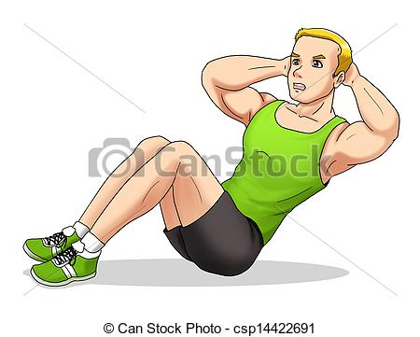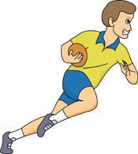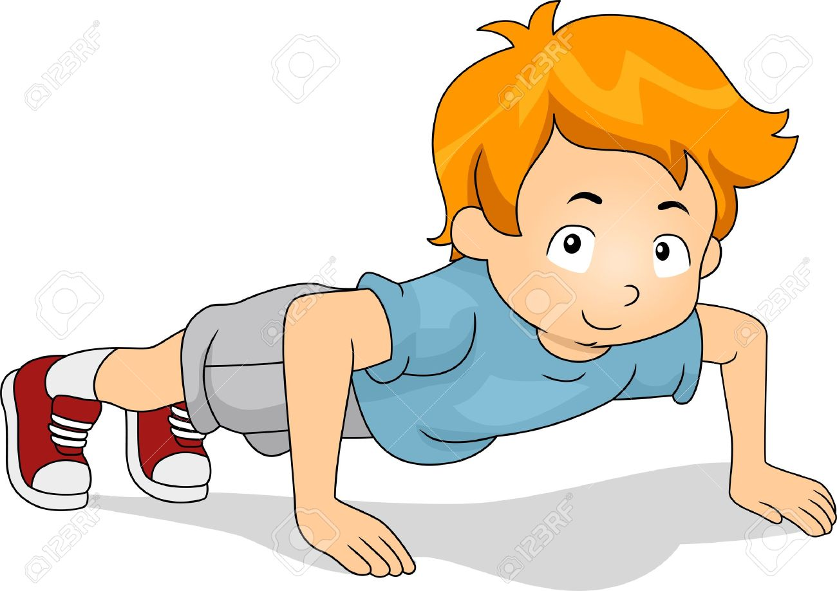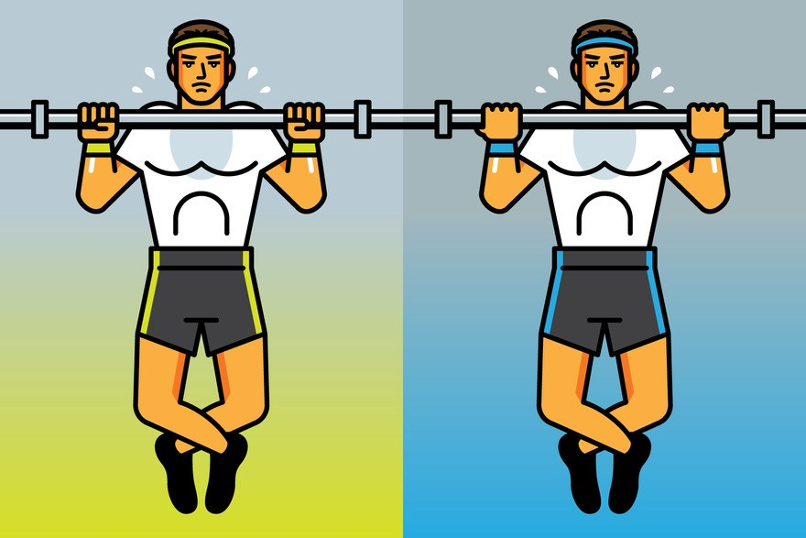

**……………….……………….……………..…………….………………..**

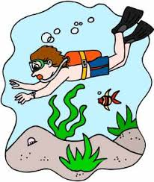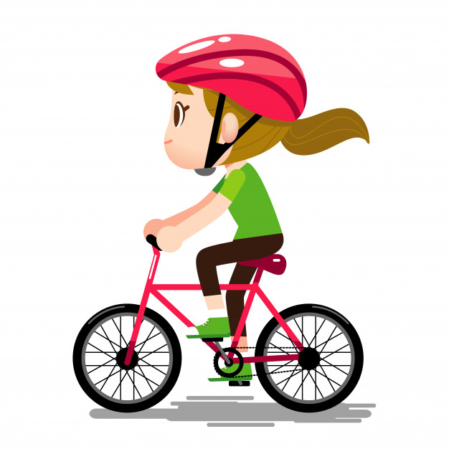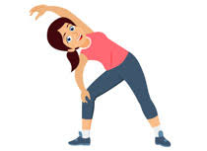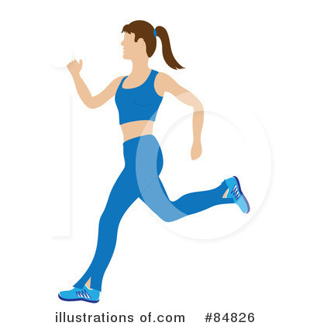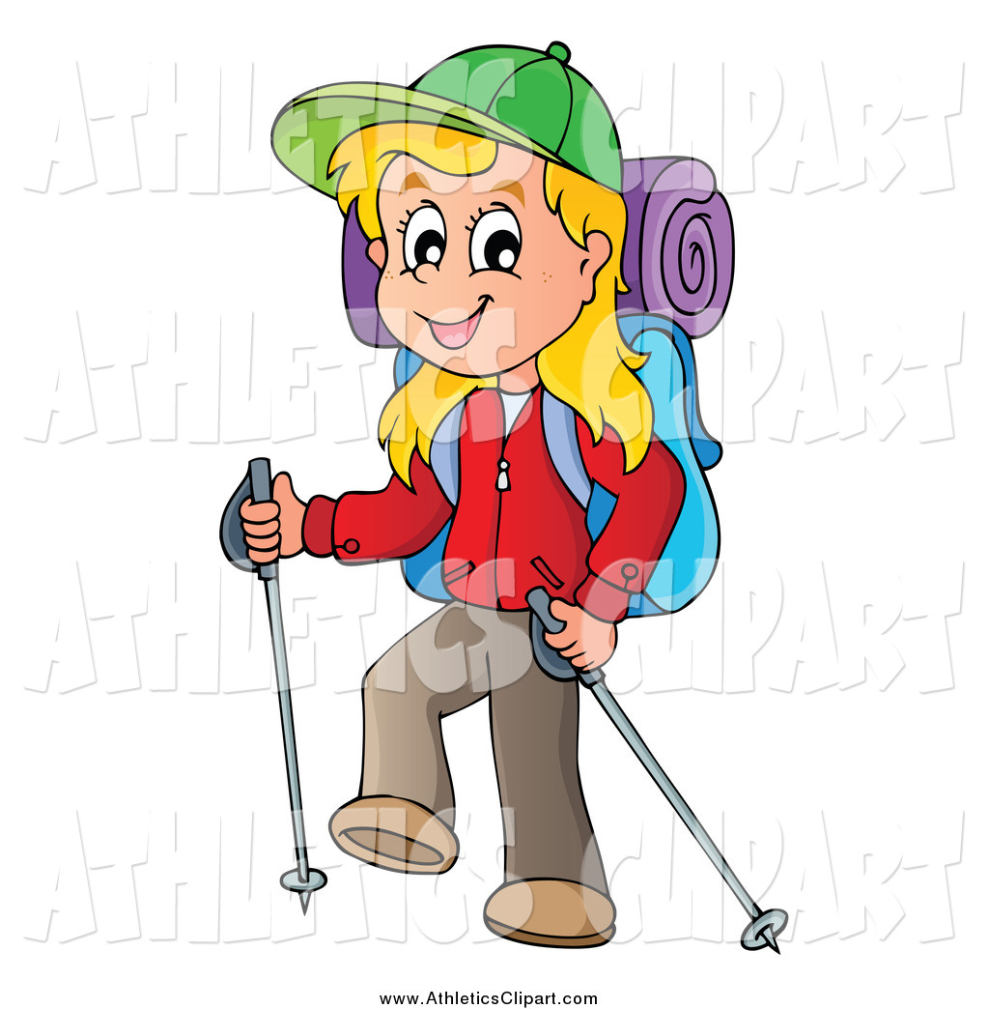

**………………………………..………………..………………….……………..**

**B .Readthepassageandwrite T (True) or F (False). (6x3=18pts.)**

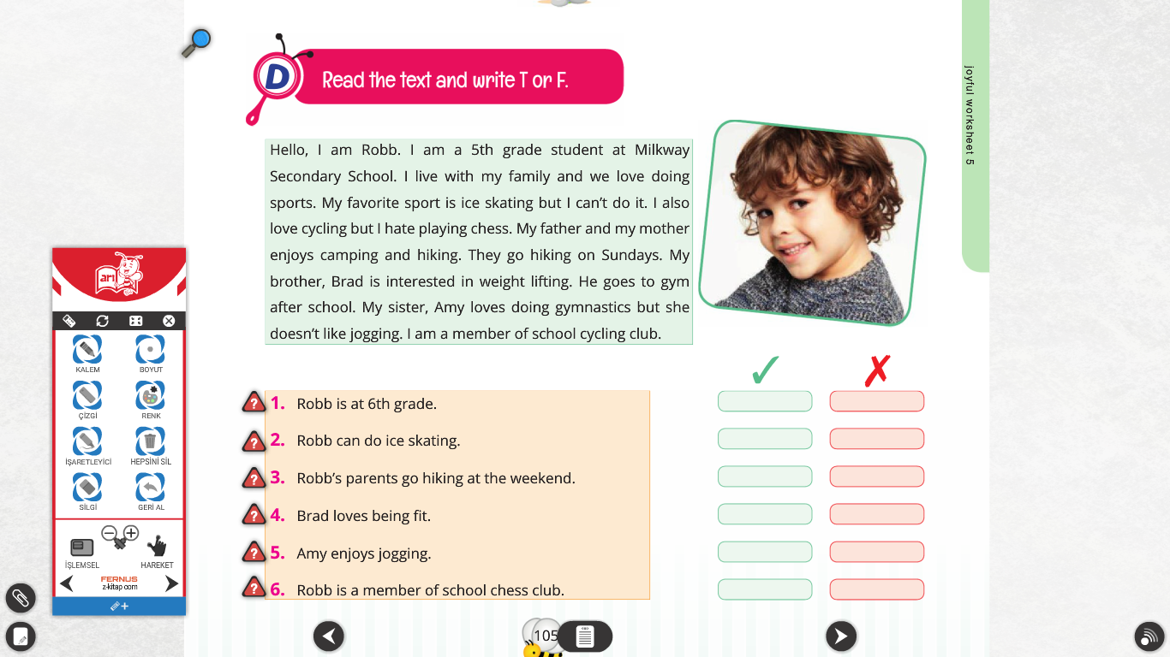

**C )Fill in the blanks with the words in the box .(8x2=16pts.)**

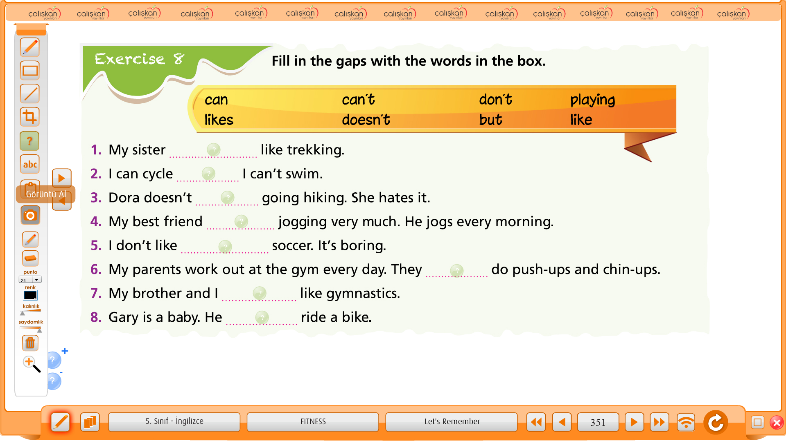

**D)Fill in theblankswith “Let’s ,Shallwe ,How about”(5x2=10pts.)**

1) ………….goswimmingthisafternoon.

2)…………….sleeping in thetenttonight?

3)……………..workingout in thegym?

4) ……………gowindsurfing?

5) …………gotothecinema.

**E )Choosetrueanswer.(5x2=10pts.)**

1) Hi Lee! ………….goingtothebeachtomorrow?

A) How about B) let’s C) Shallwe

2) Let's ____ tothebeachtomorrow. It'sgoingto be too hot.

A) togo B) going C) go

3) ____ goingtothemovies?

A) How about B) let’s C) Shallwe

4) Good idea Sam!  ___ invite Mark togowith us!

A) How about B) Let's C) Shall

5) Hi Mark. We'regoingtothemoviestomorrow. ………..tocomewith us?

A) Shallwe B) Let ‘s C) Wouldyoulike

**F )Answerthequestionsaboutyourself.(8x2=16pts.)**

1)What is yourfavouriteexercise ?5)Do youlikeplayingbaseball ?

………………………………………………………………………….

2)Do youlikecycling ? 6)Can yourenglishteacherruntwentykilometres ?

………………………………….……..……………………………

3)Whatfitnessactivity do youlike ? 7)Can youplaytabletennis ?

…………………………………….…………………..………………………..

4)Can you do push –up ? 8)Can you do karate ?

…………………………………………….……………………………

**G.Writesynonyms(5x2=10pts.)**

1. **Be form : ………………….**
2. **Hiking : …………………….**
3. **Football : ………………….**
4. **Do workout : ………………………..**
5. **Ride a bike : …………………**English TeacherMiss. KIRMACI

vderskitabicevaplarim.com