2017 – 2018 SCHOOL YEAR
YEŞİLYALI İBNİ SİNA SECONDARY SCHOOL
8th GRADE 2nd TERM 1st ENGLISH EXAMINATION

Name – Surname: Date: 30.03.2018
Number: Mark:
Class:

I’m going to attend a Halloween party on Sunday.

Yukarıdaki ifadeyi anlatan görselin bulunduğu seçeneği işaretleyiniz.

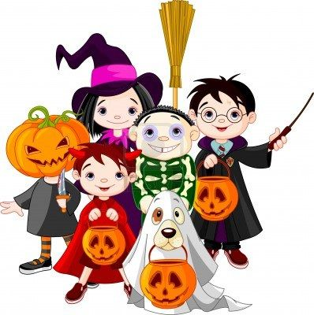
- B)

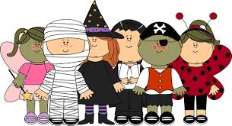
C) D)

- I’m going to invite Helen to my birthday party, but I think she is not going to come. She will - - - - - my invitation.

- welcome
- attend
- refuse
- accept

- Rosa: Which sports do you like most?
Jeff : I like the sports that don’t have physical danger.
Karşılıklı konuşmada verilen ifadeyi anlatan seçeneği işaretleyiniz.
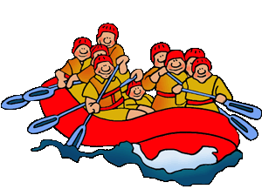
- B)

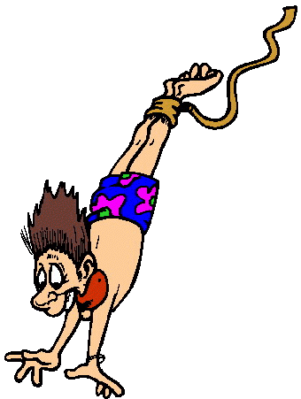
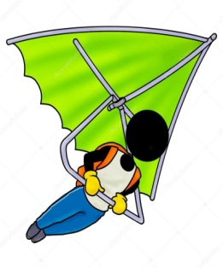
C) D)

- Sally : What type of music do you prefer?
Gale : I like pop. - - - - - ?
Sally : I love folk music.

- What do you do in the evening
- How about you
- How are you
- Do you like rap music

- Technician: Hello! How can I help you?
Customer: I have a problem with my PC.
Something destroyed my PC and
deleted all my saved information.
Technician: - - - - - ?
Customer: No. There isn’t.
Techinician: You can dowload it and use
your PC safely.

- Have you got printer
- Do you have a webcam
- Do you log on to safe websites
- Is there an anti-virus program on your PC

- Peter: Could I speak to Matt, please?
Secretary: - - - - -
Peter: Forgive me please. I need to check
the number again.

- I am sorry. He isn’t available now.
- Would you like to leave a message?
- Who is calling please?
- I think you dialed the wrong number.

- Arthur: I am an internet addict.
Samuel: What do you mean?
Arthur: I mean, - - - - -

- I hardly ever go online.
- I can’t stand playing online games.
- I think using social network is not fun.
- I am connected to the internet all the time.

- Diana: I don’t understand these people!
Tom: What do you mean?
Diana: What attracts people to do these
extreme activities?
Tom: - - - - -

- Some people don’t like taking risks.
- I agree with you. They like being indoors.
- They think these sports are safe.
- They want to see how far they can go

- - - - - - : North West of Türkiye
- - - - - : İskender kebab, candied chestnuts.
- - - - - : All inclusive and bed and breakfast
hotels.
- - - - - : cold in winters.
Boşluklara gelmesi gereken ifadeler hangi seçenekte doğru verilmiştir?

- location – cuisine – accommodation – weather
- accommodation – location – cuisine – weather
- weather – cuisine – location – accommodation
- accommodation – cuisine – location – weather
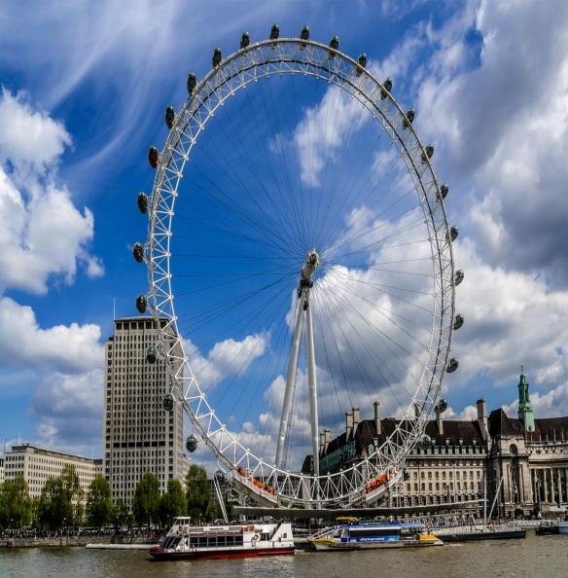

Tony hasn’t been to the - - - - - yet.

- The River Thames
- London Eye
- Big Ben
- Buckingham Palace

- Son: Can I go out and play with my friends?
Mum: Sorry, but your room was untidy. So
you can’t go out if you don’t tidy up
your room.
Son: - - - - -
Mum: So you can go. Don’t be late.

- I will tidy up my room tomorrow.
- I have already tidied up my room.
- I am not responsible for tidying up.
- I hate doing chores at home.

- Görsellere göre doğru olarak ifade edilmeyen eylem hangi seçenekte verilmiştir?

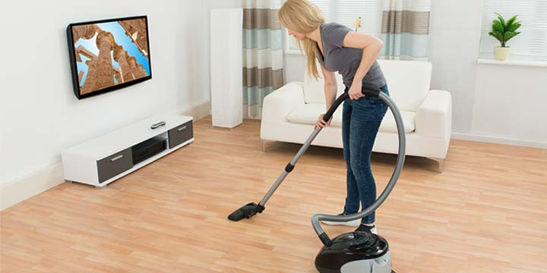

do the
vacuuming

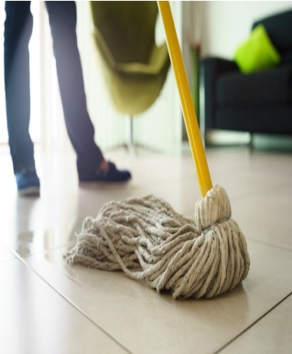

mop the floor

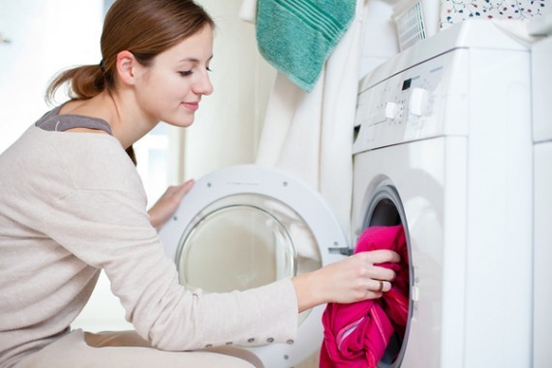

do the
washing-up

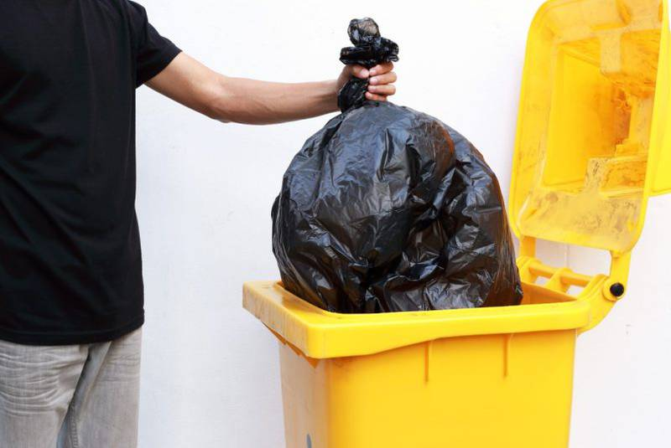

take out the
garbage

I prefer having pasta for dinner.

ifadesini anlatan görsel aşağıdakilerden
hangisidir?
- B)

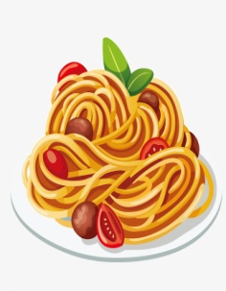
C) D)

- One of your friends invites you to a football match. However, you don’t like watching sports.

What do you say to refuse the invitation?

- I’d like to, but I’m really busy that day.
- Thanks for the invitation, but I’m not interested in sports.
- I’m really crazy about sports. Thank you!
- It sounds awesome. I’ll definitely be there.

15 – 16 – 17. soruları aşağıda verilen metne göre cevaplayınız.

I am Tom. We have a big family so there are a lot of things to do at home everyday. My father is responsible for doing the shopping and paying the bills. My mother cooks and does the laundry. She loads and empties the dishwasher. My sisters tidy up the bedrooms and living room. If you share the chores at home, you have a happy life.

- What is Tom’s mother responsibility at home?

- She is responsible for nothing.
- She has to make the meals.
- Paying the bills is her responsibility.
- She sometimes helps the others.

- Which one is true according to the passage?

- Tom have a small family.
- There are nothing to do at home everyday.
- Tom thinks you share the chores to have a happy life.
- Tom’s sisters have to nothing.

- Which one is false according to passage?

- Family members share the housework.
- His father does the shopping.
- Tom’s mother loads and empties the washing machine.
- Tom is responsible for the bathroom cleaning.

derskitabicevaplarim.com
18 – 19 – 20. soruları aşağıda verilen metne göre cevaplayınız.

Hi Ted,
I am writing to tell you about my holiday. I am having a great time here. I have seen lots of interesting things so far. Big Ben was wonderful. I went on a city tour on an open top bus. Yesterday was the sixth day of my holiday and I was on London eye. Watching the city was amazing. I bought a poster Buckingham Palace for you. I am going to be back home tomorrow.
Love,
Sally.

- Which one is true according to the passage?

- She hasn’t seen Big Ben yet.
- She didn’t buy souvenir for Ted.
- She went sightseeing.
- City view is disappointing.

- Metinde hangisinden bahsedilmiştir?

- Accommodation
- Location
- Cuisine
- Attractions

- Sally’nin kartpostalında hangi sorunun cevabı yoktur?

- What was the weather like?
- How long did you stay there?
- Have you bought any souvenirs?
- What are the main attractions?

