NAME SURNAME : NO: GRADE:7/__
- READ THE DIALOGUES PUT THE CORRECT QUESTION SENTENCE INTO THE BLANKS (15P)
-What does she like doing | -What does she look like | -What is she like

1. A: …………………………………………………………………………………….……………?
B: She is beautiful with blonde hair with blue eyes. She is tall and slim.
2. A: …………………………………………………………………………………….……………?
B: She is an outgoing girl. She has a lot of friends.
3. A: …………………………………………………………………………………….……………?
B: She likes doing outdoor sports. She goes jogging and hiking.

- FILL IN THE BLANKS WITH THE CORRECT WORD GIVEN BELOW (25 P)
-honest | -easy-going | -punctual | -selfish | -shy

- My grandmother doesn’t get angry easily. She is a calm woman. She is ……………………………… .
- Tom never tells anyone lies. He always tells the truth. He is ………………………………………. .
- I can never talk in front of the people. I’m a bit ……………………………………... .
- My teacher always comes to the classroom on time. He is …………………………………………… .
- My brother never shares anything and he just thinks about himself. He is …………………………… .

- CHOOSE THE CORRECT WORDS ACCORDING TO THE SENTENCE (15 P)
- My sister has many friends. She is outgoing / hardworking.
- My mother is rude / generous because she helps poor people.
- I am a kind / smart student because I understand and learn everything quickly.
- My friend never changes his mind. He is stubborn / forgetful.
- Melanie is a cute / quiet baby so everybody loves her.

- WRITE COMPARATIVE SENTENCES ACCORDING TO THE TABLE AS IN THE EXAMPLE
(USE THE ADJECTIVES GIVEN BELOW) (25 PTS)
Short | Tall | Fat | Slim | Hardworking | Lazy

 | HEIGHT | WEIGHT | GRADE POINTS AVERAGE
METİN | 155 cm | 70 kg | 100 pts
MARTIN | 175 cm | 60 kg | 45 pts

- Metin is shorter than Martin.
- Martin is …………………………………………..…………………………….. .
- …………………………………………………………..……………………………. .
- …………………………………………………………..……………………………. .
- …………………………………………………………..……………………………. .
- …………………………………………………………..……………………………. .
- CATEGORIZE THE GIVEN WORDS INTO THE TABLE (10 PTS)
Plump | Punctual | Helpful | Well-built | Bald
Good-hearted | Polite | Medium-height | Thin | Cheerful

APPEARANCE | PERSONALITY
1. | 1.
2. | 2.
3. | 3.
4. | 4.
5. | 5.
derskitabicevaplarim.comF) WRITE THE CORRECT WORD UNDER THE PICTURES (10 PTS)
Curly hair | Bald | Headscarf | Slim | Plump

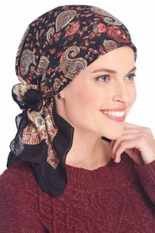 | 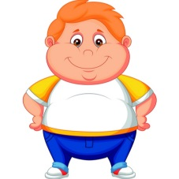 | 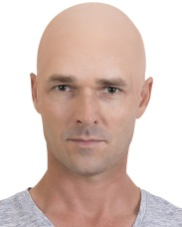 | 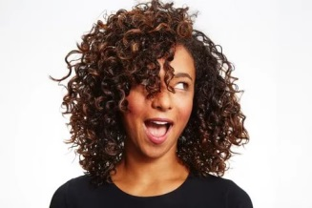 | 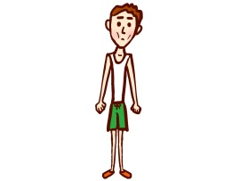
1-………………………. | 2-………………………. | 3-………………………. | 4-………………………. | 5-……………………….
BAKİ ÖZEN
İNGİLİZCE ÖĞRETMENİ

