**PERSONALITY – KİŞİLİK**

**What is she like? - O nasıl biridir?**

|  |
| --- |
| **A. studies a lot** |
| **B. sometimes breaks things** |
| **C. spends money for his/her friends** |
| **D. feels uncomfortable while talking** |
| **E. always comes appointments on time** |
| **F. doesnt change his/her mind/ideas** |
| **G. makes jokes and makes people laugh** |
| **H. never tells lies** |
| **I. learns easily and quickly** |
| **J. gets on well with everybody/is relaxed** |
| **K. doesn’t talk a lot** |
| **L. is always happy and smiles a lot** |
| **M. doesn’t like studying or working** |
| **N. always says ‘thank you’ and ‘please’** |
| **O. only thinks about himself/herself** |
| **P. has a lot of friends** |

**1.Honest___**

**2.Cheerful___**

**3.Shy___**

**4.Hardworking___**

**5.Outgoing___**

**6.Easygoing___**

**7.Clumsy___**

**8.Smart___**

**9.Polite___**

**10.Punctual___**

**11.Selfish___**

**12.Generous___**

**13.Funny___**

**14.Quiet/Calm___**

**15.Stubborn___**

**16.Lazy**

**---------------------------------------------------------------------------------------------------------------------------**

**APPEARANCE – DIŞ GÖRÜNÜŞ**

**What does she look like? – O nasıl görünüyor?**

|  |
| --- |
| **A. Güzel** |
| **B. Sakalları var** |
| **C. Zayıf** |
| **D. Başörtüsü takıyor** |
| **E. Şişman, tombul** |
| **F. Yakışıklı** |
| **G. Bıyığı var** |
| **H. Uzun boylu** |
| **I. Gözlük takıyor** |
| **J. Çirkin** |

**1. Tall ___**

**2. Slim ___**

**3. Handsome ___**

**4. Ugly ___**

**5. Beautiful ___**

**6. Fat/Plump ___**

**7. Wears glasses ___**

**8. Wears headscarf ___**

**9. Has beard ___**

**10. Has moustache ___**

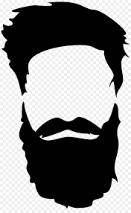

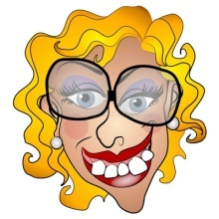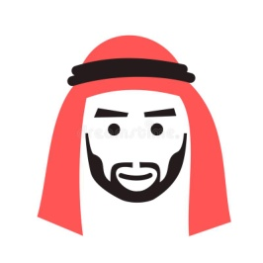



**Moustache** **Beard Headscarf Glasses Plump Ugly**

**PERSONALITY – KİŞİLİK**

**What is she like? - O nasıl biridir?**

|  |
| --- |
| **A. studies a lot** |
| **B. sometimes breaks things** |
| **C. spends money for his/her friends** |
| **D. feels uncomfortable while talking** |
| **E. always comes appointments on time** |
| **F. doesnt change his/her mind/ideas** |
| **G. makes jokes and makes people laugh** |
| **H. never tells lies** |
| **I. learns easily and quickly** |
| **J. gets on well with everybody/is relaxed** |
| **K. doesn’t talk a lot** |
| **L. is always happy and smiles a lot** |
| **M. doesn’t like studying or working** |
| **N. always says ‘thank you’ and ‘please’** |
| **O. only thinks about himself/herself** |
| **P. has a lot of friends** |

**1.Honest___**

**2.Cheerful___**

**3.Shy___**

**4.Hardworking___**

**5.Outgoing___**

**6.Easygoing___**

**7.Clumsy___**

**8.Smart___**

**9.Polite___**

**10.Punctual___**

**11.Selfish___**

**12.Generous___**

**13.Funny___**

**14.Quiet/Calm___**

**15.Stubborn___**

**16.Lazy**

**---------------------------------------------------------------------------------------------------------------------------**

**APPEARANCE – DIŞ GÖRÜNÜŞ**

**What does she look like? – O nasıl görünüyor?**

|  |
| --- |
| **A. Güzel** |
| **B. Sakalları var** |
| **C. Zayıf** |
| **D. Başörtüsü takıyor** |
| **E. Şişman, tombul** |
| **F. Yakışıklı** |
| **G. Bıyığı var** |
| **H. Uzun boylu** |
| **I. Gözlük takıyor** |
| **J. Çirkin** |

**1. Tall ___**

**2. Slim ___**

**3. Handsome ___**

**4. Ugly ___**

**5. Beautiful ___**

**6. Fat/Plump ___**

**7. Wears glasses ___**

**8. Wears headscarf ___**

**9. Has beard ___**

**10. Has moustache ___**







**Moustache** **Beard Headscarf Glasses Plump Ugly**

**derskitabicevaplarim.com**