NAME SURNAME : NO: GRADE:6/__
- WRITE THE DAYS OF THE WEEK (10 P)
- M o n d a y
- T _ _ _ _ _ _
- W _ _ _ _ _ _ _ _
- T _ _ _ _ _ _ _
- F _ _ _ _ _
- S _ _ _ _ _ _ _
- S u n d a y

- WRITE THE MONTHS OF THE YEAR (20 P)

- J a n u a r y
- F _ _ _ _ _ _ _
- M _ _ _ _
- A _ _ _ _
- M _ _
- J _ _ _
- J _ _ _
- A _ _ _ _ _
- S _ _ _ _ _ _ _ _
- O _ _ _ _ _ _
- N _ _ _ _ _ _ _
- D e c e m b e r

- WRITE THE TIMES AS IN THE EXAMPLE GIVEN BELOW (20 P)
- 11:10 = It’s ten past eleven.
- 08:30 = ........................................................
- 10:15 =........................................................
- 11:55 =........................................................
- 12:45 =........................................................
- 03:00 =........................................................

- WRITE THE DATES AS IN THE EXAMPLE GIVEN BELOW (15 P)
- 15/07= the fifteenth of July.
- 23/04= ………………………………………………. .
- 01/01= ………………………………………………. .
- 31/12= ………………………………………………. .
- 19/05=………………………………………………. .
- 30/08=………………………………………………. .
- WRITE THE YEARS AS IN THE EXAMPLE GIVEN BELOW (15 P)
- 1923= nineteen twenty-three
- 2019= two thousand and nineteen
- 1453=…………………………………………………….
- 1881=…………………………………………………….
- 1984=…………………………………………………….
- 2023=…………………………………………………….
- 2071=……………………………………………………. derskitabicevaplarim.com
- WRITE THE NAMES OF ACTIVITIES UNDER THEIR PICTURES. (20 P)
a. run errands b. take care of pet c. visit grandmother d. wake up e. play football f. have breakfast g. take folk dance courses h. rest i. finish all homework j. go to bed
  1………………..…… | 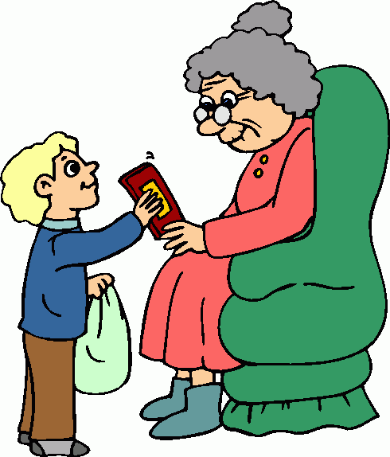  2…………..……… |   3………………….… |   4……………………. |   5…………………..
  6…………………..… |   7…………………….. |   8……………….…. |   9…………………… |   10…………….…..
BAKİ ÖZEN
İNGİLİZCE ÖĞRETMENİ

