**derskitabicevaplarim.com**

**6’th GRADE- UNIT 1- QUİZ 1**

**Name: Surname:**

|  |  |  |  |  |  |
| --- | --- | --- | --- | --- | --- |
| 1 | Study |  | 21 | Take a nap |  |
| 2 | Rest |  | 22 | Play tennis |  |
| 3 | Run errands |  | 23 | Wake up |  |
| 4 | Visit grandmother |  | 24 | Have lunch |  |
| 5 | Help dad |  | 25 | Student |  |
| 6 | Do jogging |  | 26 | Lesson |  |
| 7 | Have breakfast |  | 27 | Visit |  |
| 8 | Take care of dog |  | 28 | Usually |  |
| 9 | Diary |  | 29 | After that |  |
| 10 | Watch tv |  | 30 | Traditional |  |
| 11 | Play chess |  | 31 | folk dance |  |
| 12 | Finish |  | 32 | Before dinner |  |
| 13 | After school |  | 33 | Date |  |
| 14 | Morning |  | 34 | Friend |  |
| 15 | Finish homework |  | 35 | Mommy |  |
| 16 | Tea Party |  | 36 | Listen teacher |  |
| 17 | Weekdays |  | 37 | Every night |  |
| 18 | Sleepy |  | 38 | p.m. |  |
| 19 | Quarter past |  | 39 | Cooking |  |
| 20 | Quarter to |  | 40 | Aunt |  |
|  |  |  | 41 | What time is it? |  |

**Boşlukları yanda verilen uygun kelimelerle dolduralım.**

learn folk dance

2. go to chess club

meets her friends

1. rests for a whil
2. have a big family breakfast
3. tidy my room
4. drink coffee
5. goes to bed
6. I ........................................ every morning because it helps me to wake up.
7. Albert ........................................ early because he doesn’t like getting up late.
8. Phoebe ........................................ after work because she is very tired.
9. She doesn’t want to .................................... because she can’t dance.
10. I ........................................ every week. I like playing it very much.
11. We ........................................at home every Sunday morning. It is very delicious.
12. I never ........................................because my mother does it for me.
13. Ruby ........................................ on Wednesday at their favorite cafe. They eat and chat there.

Relatives

English

Snack

Room

Homework

Dance club

Rest

Lunch

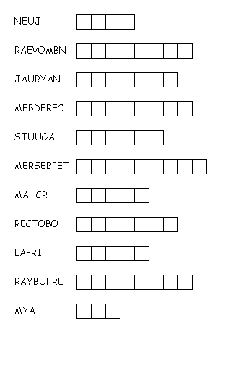

**Verilen ayları düzenleyelim ve karşılarına türkçelerini yazalım.**

**Verilen haftanın günlerinin türkçelerini yazalım.**

Wednesday : ………… Sunday:……… Thursday:………….. Saturday:………. Monday:………… Friday:………. Tuesday:…………

**Aşağıda verilen saatlerin cümlelerini yazalım.**

02:13 = ……………………………………

10:30=……………………………………..

08.15=…………………………………….

06:45= …………………………………….

07:00=…………………………………….

06.47=…………………………………….

09:45=……………………………………

04:38=……………………………………..

I LOVE YOU ! Good Luck ! ( Sizi seviyorum, Başarılar)

☺ <3 <3 <3 ☺

Ezgi Asker

Minik bir ipucu: ☺

Half past: Buçuk O’clock: Tam saat

To: Var Past: Geçiyor A quarter: Çeyrek