**QUIZ - UNIT 8 DEDECTIVES AT WORK**

**A) Resimlerin yanındaki kutucuklara uygun kelimenin numarasını yazın (20x2=40p)**

**1)**glasses **2)**magnifier **3**)footprint **4**)security camera **5)**thief **6)**inspector

**7)**jewelery **8)**burglar **9**)cash **10)**prison **11)** police officer **12**) fingerprint **13**)mask **14**)drawer **15**)binoculars **16**)break into **17**)investigate **18**)chase **19)**witness **20)**microscope

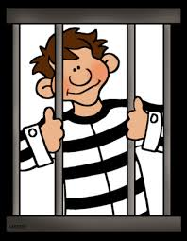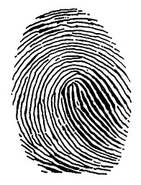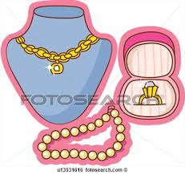

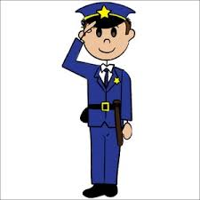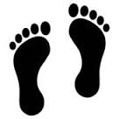

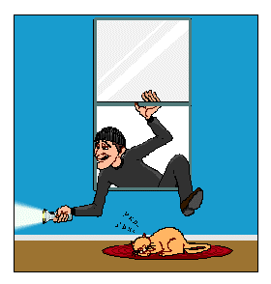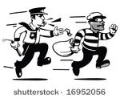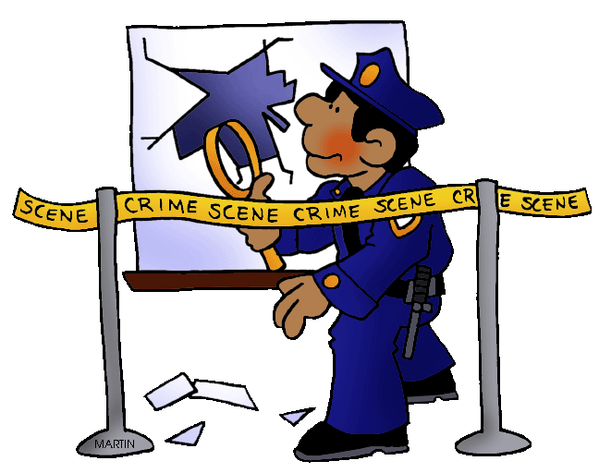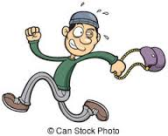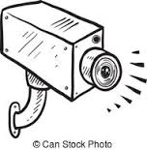

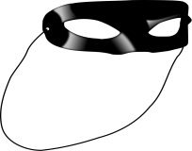

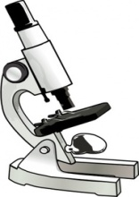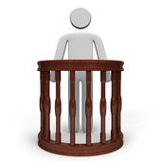

**B) Aşağıdaki ifadeleri Türkçeleri ile eşleştiriniz.(8x2=16p)**

a) takip etmek

b) dil

c) içine koymak

d) ip ucu

e) örnek

f) taşımak

g) silah

h) para çakmek

1. carry ______

2. clue ______

3. draw out ______

4. follow ______

5. gun ______

6.language ______

7. sample ______

8. put into______

**C) Örnek cümleye bakarak resimlere göre nesnelerin yerlerini İngilizce yazın. (7x2=14p)**

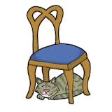 (in - on- in front of - behind - near - between - under)

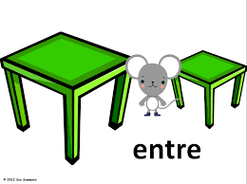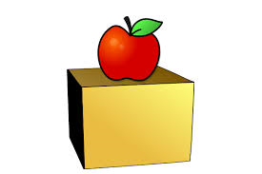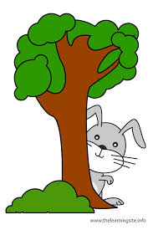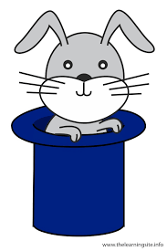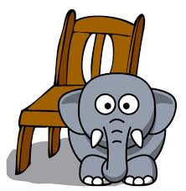

………………… ………………… ..………… … ……….… .…………… . .……………… …..…………… …………………

**D) Aşağıdaki sayıların İngilizce okunuşlarını yazın. (8x2=16)**

673 : ________________________________________________________________

419 : ________________________________________________________________

3528 : ________________________________________________________________

2164 : ________________________________________________________________

13.500 : ________________________________________________________________

450.000 : _______________________________________________________________

582.784 : ______________________________________________________________

1.000.000 : ____________________________________________________________

**E) Verilen kelimelerle şimdiki zamanda cümle kurun. (5x2=10p)**

1. Ahmet - play - football - now _______________________________________________

2. I - drink - lemonade - now _________________________________________________

3. We - have - dinner - now _________________________________________________

4. I -ride - mybicycle - now _________________________________________________

5. They- walk - in the park - at the moment _______________________________________

[https://www.HangiSoru.com](https://www.HangiSoru.com/)

**F) Soruları parantez içindeki bilgilere göre cevaplayın. (2x2=4p)**

1. What is your mother doing now? (cook)

_______________________________________________________

2. What is Jack doing now? (draw picture)

_______________________________________________________

derskitabicevaplarim.com