|  |  |  |  |  |
| --- | --- | --- | --- | --- |
| **derskitabicevaplarim.comimages** | **www.HangiSoru.com ACADEMIC YEAR MUSTAFA KEMAL SECONDARY SCHOOL 1st TERM 1st ENGLISH QUIZ FOR 5th GRADE** | | | **POINT:** |
| **Name&Surname:** | | **Class:** | **Number:** | **Duration: 40 min.** |

A. ANSWER THE QUESTIONS. (6x4=24)

1. What is your name? ………………………………………………………………………………………

2. How old are you? …………………………………………………………………………………………

3. Where are you from? ………………………………………………………………………………………

4. What is your mother name? ………………………………………………………………………

5. What is your favorite class? ……………………………………………………………………………………..

6. Do you like English? ………………………………………………………………………………………………….

B. FILL IN THE BLANKS WITH CLASSES. (5x3=15)

1. I like solving problems. My favorite class is ………………….…………..…….. 

2. I love learning languages. My favorite class is ………………………………… 

3. I enjoy doing experiments. My favorite class is ………………………...……….. 

4. I dislike sports. I don’t like ………………………………………………………………

5. I love drawing pictures. My favorite class is ……………………………………… 

**C. FILL IN THE BLANKS ACCORDING TO THE TEXT.** **(5x2=10)**

|  |  |  |  |  |  |
| --- | --- | --- | --- | --- | --- |
| Murat is from Turkey. He is Turkish. He is eleven years old. He speaks Turkish and English. He likes Maths and Art. | | | | | |
|  | COUNTRY | NATIONALITY | AGE | LANGUAGES | LIKES |
| MURAT |  |  |  |  |  |

**D. FILL IN THE BLANKS WİTH *‘m – is – are.*** **(12x1=12)**

**1.** I _________ a teacher. **2.** They _______ yellow cards.

**3.** Steve and Tim ________ hardworking. **4.** Susan _______ at school.

**5.** He _______ late. **6.** We _______ a team.

**7.** You _______ beautiful. **8.** Mary _______ nervous.

**9.** I ________ sorry. **10.** She _______ a nice girl.

**11.** It ______ a black dog. **12.** You _______ good students.

E. WRITE THE NAMES OF THE OBJECTS.(20x2=40)

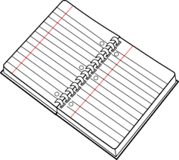 

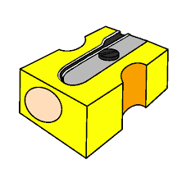



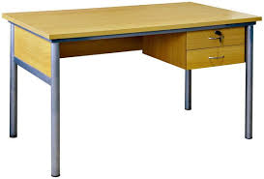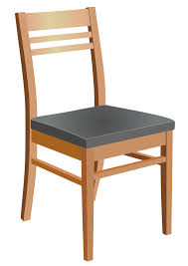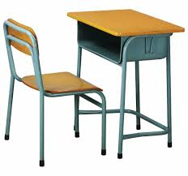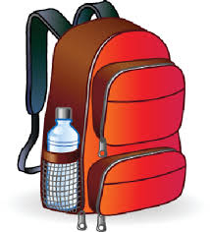

**GOOD LUCK ^_^**