5^{TH.} GRADE
SELF TEST
EXERCISES:
Fill in theblankswiththesuitablewordsbelow.
A - (need-have-find -remove-draw-count -different-lives-turns-)
- The ‘’ it’’ ---------- his back in thehideandseek.

- I------ thestamps on theenvelopeformycollection.
- I havea lot of friendsfrom --------- countries.
- Paul ------- with his family in Madrid .
- I ------- 60 stampscollection.
- Youmust ------ checkers on thefloortoplayhopcsotch.
- We --------- a ballandrackettoplaytennis.
- I--------- fromonetotwentyandtryto -------- myfriends.

B- ( run-speak- draw- do-sculpting -hop- play (2) –ride-skip )
- She is from Germany . Shecan------------ German.
- Sally’sfavouriteclass is Music. She can ------- theguitar.
- My grandma is veryold . Shecan’t ----------- fast.
- David is 2 yearsold . He can’t ------- a horse.
- I can’t -------chess. I’m bad at it.
- My sister is verygood at Art. She can ---------- pictureswell.
- I can’t ------- thispuzzle. It’sverydifficult.
- Rabbits can ------ andrunfast.
- My littlesister can --------- rope. She is reallygood at it.
10. I like Art. I’m good at doing -------------.
C.ANSWER THE FOLLOWING QUESTIONS
1.What do youlikedoing in yourfree time ?
--------------------------------------------------------.
2. Whatareyourhobbies ?
---------------------------------------------------.
3. Wholikesplayingchess in yourfamily ?
-----------------------------------------------------

4. Can youplaycheckers ?
---------------------------------------.
5. Where do youplayhopscotch ?
-------------------------------------------.
6. Do youenjoyplayingChineseWhisper ?
------------------------------------------
7. Whichlanguage can youspeak ?
------------------------------------------
8.Where doesyourgrandfatherlive ?
------------------------------------------
 |     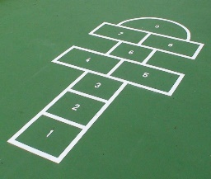 | 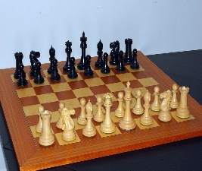 | 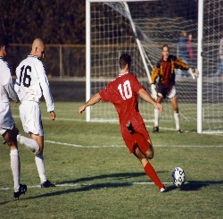 | 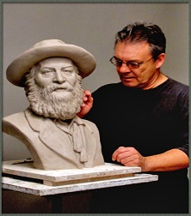 | 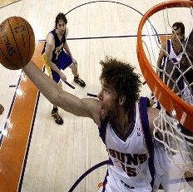
HELEN |  |  | 
BOB
SUE
TOM

- Helen / like/play / hopscotch /
----------------------------------------
- Helen / like / do / sculpting/
------------------------------------------
- Bob /like/ play / basketball/
------------------------------------------
- Bob/ like/ play/ football./
--------------------------------------------
5.Sue/like / play/ chess /
---------------------------------------------
- Tom/ like/ do/ sculpting./ derskitabicevaplarim.com
Lütfiye TIN

