(8)
I live in the farm and I have wonderful wool.
(6)
I’m gray and huge and I’m famous for my trunk.
(3)
People like to put me in aquariums. But I prefer the large blue sea.
(10)
You can find me in the farm and I give you the delicious milk.
(1)
You can keep me at home and I will help you catching mice!
(4)
I like to open my wings and fly in the blue sky.
(7)
I’m so small and I have a long tail. I live in the fields and eats maize and cheese.
(9)
I have long ears and I go like” hiha..hiha”

(12)
I can climb tress and I’m crazy about bananas.
(2)
I’m a good guard. When a stranger comes near the house I go like “wouf.. wouf”!
(5)
I have a long neck to help me reaching the delicious green leaves.
(11)
I have strong legs that help me to run fast.
Date:
Oğuzhan KOÇAK
İNGİLİZCE ÖĞRETMENİ

Who am I ?






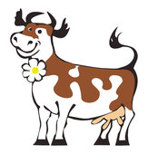
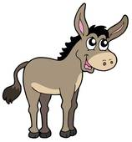

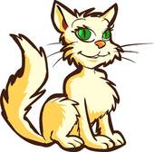
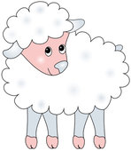

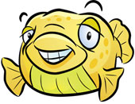

Who am I ?



