**5.1.2 YAZILIYA HAZIRLIK KAĞIDI _ 3,4,5. ÜNİTELER AĞIRLIKLIDIR**

**A_ Verilen resimlerin altına hastalıkların İngilizcelerini yazınız. >>** Headache - Toothache -Measles - Backache- Fever- Stomachache

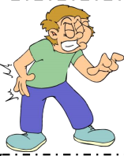 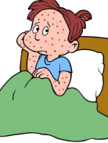 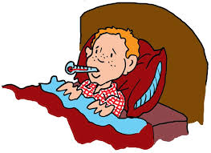 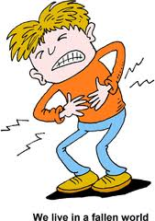 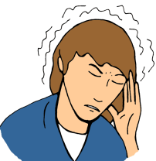 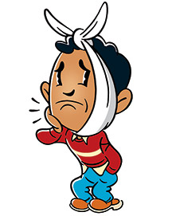

_______________ _______________ _______________ _______________ _______________ _______________

**B) oyunların İngilizce karşılıklarını yazınız. >>** *play chess *do origami *do puzzle *play hopscotch *play blind man's buff

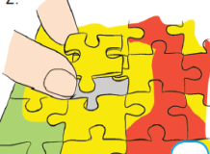 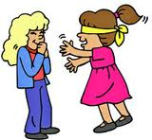 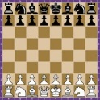 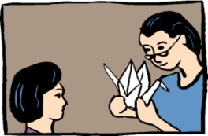

1.________________ 2.________________ 3.________________ 4._________________ 5._________________

**C) What time is it? (Saat kaç?)** 1. It is quarter past two. **D) Soruların cevaplarını seçerek yazınız.**

2. It is half past five. 3. It is quarter to one. 4. It is five o'clock. 1. Where are you from ? a. yes, I can

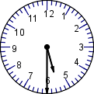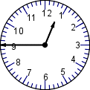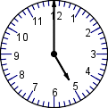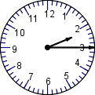  2. What is your name? b. Geography

3. Can you speak French? c. Two.

4. How many languages do you speak? d. fifteen

5. How old are you? e. Tom

_____ ____ ____ ____ 6. What is your favourite lesson? f. Ireland.

Hello! I am Rose. I get up at half past seven. I have breakfast at eight o'clock. I get dressed and go to school by bus. I have lunch at school canteen. I come back home at four o'clock. After school, I go online and read book. I go to bed at ten o'clock.

1. What time does Rose get up ? 3. How does Rose go to school ?

2. Where does Rose have lunch ? 4. Does Rose go online ?

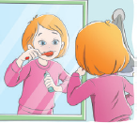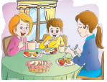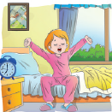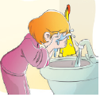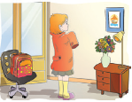**Aktivitelerle resimleri eşleştirin >>>** brush teeth get ready for school wash hands and face have breakfast get up

**___________________________________ ___________________________________ ___________________________________ ___________________________________ ______________________________**

Sorularla cevaplarını eşleştirin Sayıların İngilizcelerini yazınız

- What time do you get up? (……..) 1. I go to school by school bus. 10.

- **What** do you do after school? (……..) 2. I get up at 7 o’clock. 12.  
 - **How** do you go to the school ? (……..) 3. No, she can’t. 25.  
 - **Do** you have breakfast in the mornings? (……...) 4. I watch TV and do my homework. 40.

- **Can** Ceren ride a bike? (……...) 5. Yes, I do. 76.

**Kelimelerin manalarını yazınız :**

Between : Next to : In front of: On : In :

**Doğru seçeneği yuvarlak içine alınız**

1. We play / plays football at weekends. 4. I don’t / doesn’t watch TV every day.

2. Nuri don’t / doesn’t have breakfast in the mornings 5. **Do / does** you get up early every morning?

3. Beyaz and Emine **study / studies** English every evening.

**manalarını yazınız :**

checkers hopscotch play marbles hide and seek skip rope

chess playing tag do origami tic-tac-toe do puzzles

**T/F**

Emre gets up at seven o’clock. Then, he has breakfast at eight o’clock. After that, he goes to school at quarter past nine. He has lunch at half past twelve. He leaves school at four o’clock. He arrives home at half past four.

Emre gets up at 07:00. **………………** Emre has breakfast at 9:00. **………………** Emre goes to school at 10:00. **………………**Emre has lunch at 12:30. **………………** Emre leaves school at 04:00 **………………**

**G)** **Complete the chart**

|  |
| --- |
| Germany |
| German |
| German and English |
| Science and Music |
| Mario Gomez |

|  |  |
| --- | --- |
| Name |  |
| Country |  |
| Nationality |  |
| Languages |  |
| Favourite Lessons |  |

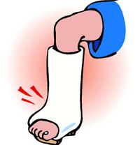 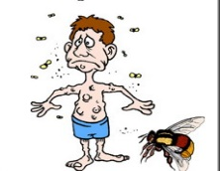 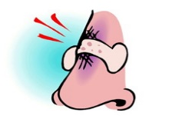 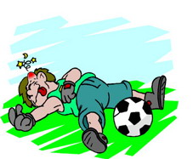 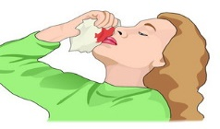 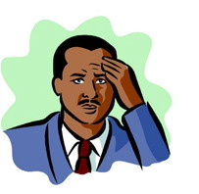

Broken nose vomit Broken nose a toothache a backache a toothache

Broken arm cold Broken arm a cough runny nose a backache

Broken leg a sore troath Broken leg a bump broken nose a stomachache

Flu bee sting A headache a runny nose flu a headache

**Complete the sentences with the words in the box**. **Match the situations with the advice.**

shower / junk food / plaster / healthy / cold water 1 I have got a sore throat. a You should use a plaster.

1 You can buy _________________ at a pharmacy. 2 I have got a cut on my finger. b You should see a dentist.

2 I feel _________________ because I do exercise every day. 3 I have got a backache. c You should drink hot tea.

3 I have a temperature. I should have a _________________ . 4 I have got a toothache. d You shouldn’t eat ice-cream.

4 I have a terrible cough. I shouldn’t drink _________________. 5 I have got a runny nose. e You shouldn’t carry heavy things.

5 You shouldn’t eat _________________ to be healthy.

**Complete the sentences with the words in the boxes**. >>

|  |
| --- |
| **tea / shouldn’t / should / hot / fever** >> George has got a ____________ . He feels ___________________ . He ___________________ stay at home. He __________________ go out. He should drink ___________________ . He should have a shower. |
| **Bad / take / flu / should / shouldn’t** >>> Chris has got the ___________________ . He feels ___________________ . He ___________________ stay in bed. He ___________________ go to school. He should ___________________ some vitamins. |
| **mint and lemon tea / stomachache / rest / cold water / shouldn’t** >> Susan has got a ________________ . She shouldn’t drink _____________ . She should drink _________________ . She _________________ eat junk food. She should have a _________________ . |

**True or False**

1 Brad should drink coke every day. _____ 4 Jason shouldn’t eat junk food. _____

2 Jack shouldn’t have breakfast every morning. _____ 5 Alice should brush his teeth three times a day. _____

3 Monica should eat a lot of chocolate, cake and candies. ___

**Fill in the blanks with the words in the box**. >>>> collecting / at (x2) / plays (x2) / favourite / on / goes / taking / doing

Jim likes ______________ stamps. He hates ______________ puzzle. He ______________ basketball ______________ half past four ______________ Sundays. He ______________ to the origami club on Wednesdays. He likes ______________ photos. He ______________ dodgeball in the garden ______________ the weekends. His ______________ games are chess and checkers.

**Fill in the blanks with can / can’t.** 1 A parrot ______________ speak but it ______________ swim.

2 A fish ______________ fly but it ______________ swim. 4 A rabbit ______________ speak but it ______________ run very fast.

3 An elephant ____________ run but it ____________ walk. 5 A dog ______________ swim but it ______________ fly.

**A: Fill in the blanks.** **E: Complete the sentences**  like(s) √ love(s) √√ don’t / doesn’t like X

Country Nationality 1 √ Jack __________________ Science.

Turkey _______________ 2 X They _____________________ Music.

_______________ French 3 √√ Pamela ____________________ PE

Italy _______________ 4 √ Anna and Kim _________________ Social Studies.

_______________ Chinese 5 X Jessica __________________ soccer.

USA ________________ 6 √ David ___________________ swimming.

Japan ________________

**can / can’t**

play / sing / speak / use / do / draw / solve

1 I _________________________ the piano. (√) 6 I _________________________ the computer. (X)

2 I _________________________ experiments. (√) 7 I _________________________ soccer. (X)

3 I _________________________ math problems. (√) 8 I _________________________ French. (X)

4 I _________________________ gymnastics. (√) 9 I _________________________ tennis. (X)

5 I _________________________ pictures. (X) 10 I _________________________ songs. (√)

**F: Answer the questions according to the timetable**. Monday Tuesday Wednesday Thursday Friday

1 What’s on Wednesday? _______________________________. Social Studies Maths Turkish English Art

2 When is PE? ________________________________________. Social Studies Maths Turkish English Music

3 What’s on Thursday? _________________________________. Art English Science Turkish Social Studies

4 When is Maths? _____________________________________. Art English Science Turkish Social Studies

5 When is Social Studies? ________________________________ . Comp. Studies Music Maths PE Science

Comp. Studies Music Maths PE Science