**ÇEŞTEPE İLKÖĞRETİM OKULU 2018-2019 EĞİTİM ÖĞRETİM YILI 5. SINIF İNGİLİZCE DERSİ YETİŞTİRME KURSU DEĞERLENDİRME SINAVI**

1. **Aşağıdaki soruları verilen bilgilere göre cevaplayın. (3 pts each)**

MCj01993520000[1] MCj03074220000[1] MCj04242240000[1]  

1. Whose stethoscope is this?
2. Whose hammer is that?
3. Whose calculator is that?
4. Whose rulers are these?
5. Whose alarm clock is that**?**

Mert

Can

Mutlu

Selma

My sister

1. **Aşağıdaki tabloya bakın ve boşlukları “like / likes / don’t like / doesn’t like” ile doldurun. (2 pts each)**

|  |  |  |  |
| --- | --- | --- | --- |
| **kid_clipart_boy_smilingTIM** |  | **22031494** | **C:\Program Files\Microsoft Office\MEDIA\OFFICE12\Bullets\BD14753_.gif20460963** |
| **kid_clipart_shy_girlLYNN** | **swim1** | **C:\Program Files\Microsoft Office\MEDIA\OFFICE12\Bullets\BD14753_.gifC:\Program Files\Microsoft Office\MEDIA\OFFICE12\Bullets\BD14753_.gif22031494** | **C:\Program Files\Microsoft Office\MEDIA\OFFICE12\Bullets\BD14753_.gif20460963** |

1. Tim \_\_\_\_\_\_\_\_\_\_\_\_\_\_\_\_\_ playing football.
2. Lynn \_\_\_\_\_\_\_\_\_\_\_\_\_\_\_\_ playing football.
3. Tim and Lynn \_\_\_\_\_\_\_\_\_\_\_\_\_\_\_\_\_\_\_\_ swimming.
4. They \_\_\_\_\_\_\_\_\_\_\_\_\_\_\_\_\_\_\_\_\_\_\_ playing chess.
5. Tim \_\_\_\_\_\_\_\_\_\_\_\_\_\_\_\_\_\_\_\_\_\_\_\_ playing chess.
6. Lynn \_\_\_\_\_\_\_\_\_\_\_\_\_\_\_\_\_\_\_ swimming.
7. **Tabloya göre soruları cevaplayın. (3 pts each)**
8. Does Tim like swimming?
9. Does Lynn like playing football?
10. Do Tim and Lynn like swimming?
11. Do Tim and Lynn like playing chess?
12. Does Tim like playing football?
13. Does Lynn like playing chess?
14. **Sorularla cevapları eşleştirin. (2 pts each)**
15. No, I don’t.
16. No, she doesn’t.
17. Yes, he does.
18. No, we don’t.
19. Yes, they do.
20. Do Mary and Penny like ballet?
21. Does George like football?
22. Do you and Ben like tenis?
23. Do you like basketball?
24. Does Clarie like volleyball?
25. **[](http://www.signsbyyou.com/decals/graphic_decal_10089.htm)Resimlere göre soruları cevaplayın. (3 pts each)**

**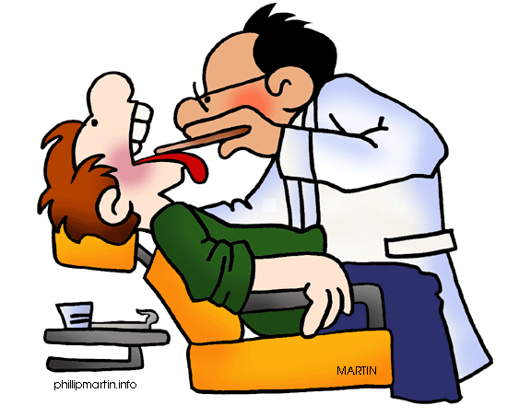[](http://www.signsbyyou.com/decals/vinyl-decal-130797.htm)**

[](http://www.signsbyyou.com/decals/vinyl-decal-343106.htm) [](http://www.signsbyyou.com/decals/vinyl-decal-388174.htm)

1. What’s his job? \_\_\_\_\_\_\_\_\_\_\_\_\_\_\_\_\_\_\_\_\_\_\_\_\_\_\_\_\_\_\_\_\_\_\_\_\_\_\_\_\_\_\_
2. What’s his job? \_\_\_\_\_\_\_\_\_\_\_\_\_\_\_\_\_\_\_\_\_\_\_\_\_\_\_\_\_\_\_\_\_\_\_\_\_\_\_\_\_\_\_\_\_\_\_
3. What’s his job? \_\_\_\_\_\_\_\_\_\_\_\_\_\_\_\_\_\_\_\_\_\_\_\_\_\_\_\_\_\_\_\_\_\_\_\_\_\_\_\_\_\_\_\_
4. What’s her job? \_\_\_\_\_\_\_\_\_\_\_\_\_\_\_\_\_\_\_\_\_\_\_\_\_\_\_\_\_\_\_\_\_\_\_\_\_\_\_\_\_\_\_
5. What’s his job? \_\_\_\_\_\_\_\_\_\_\_\_\_\_\_\_\_\_\_\_\_\_\_\_\_\_\_\_\_\_\_\_\_\_\_\_\_\_\_\_\_\_\_\_
6. **Boşlukları kutu içindeki kelimelerle doldurun. (2 pts each)**

**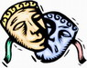**

My Your

Their Our

His Its

Her

I am an actress. This is \_\_\_\_\_\_\_\_\_\_\_\_ mask.

[http://t2.gstatic.com/images?q=tbn:U-da7iL7tguc-M:http://www.medikal-market.com/cgi-bin/resimler/litman_pediatrik.jpg](http://images.google.com.tr/imgres?imgurl=http://www.medikal-market.com/cgi-bin/resimler/litman_pediatrik.jpg&imgrefurl=http://www.medikal-market.com/SHOP/urundetayopt.asp?product=3606&usg=__AyrtjrVNJ33jl-GLbA0gl-f--ys=&h=718&w=261&sz=19&hl=tr&start=17&um=1&itbs=1&tbnid=U-da7iL7tguc-M:&tbnh=140&tbnw=51&prev=/images?q=steteskop&um=1&hl=tr&sa=X&tbs=isch:1)[](http://images.google.com.tr/imgres?imgurl=http://www.picturesof.net/_images/Cartoon_Blow_Dryer_Royalty_Free_Clipart_Picture_081130-013249-207042.jpg&imgrefurl=http://www.picturesof.net/search_term_pages/hair_dryer.html&usg=__WxVve9nM2aXqIXDR2bTsA4epzT4=&h=100&w=75&sz=2&hl=tr&start=3&um=1&itbs=1&tbnid=KcU2SVoMlPPQcM:&tbnh=82&tbnw=61&prev=/images?q=hair+dryer+cartoon&um=1&hl=tr&tbs=isch:1) My sister is a hairdresser. This is \_\_\_\_\_\_\_\_\_ hairdryer.

 John is a doctor. This is \_\_\_\_\_\_\_\_\_\_\_\_\_ stethoscope.

[](http://images.google.com.tr/imgres?imgurl=http://www.clker.com/cliparts/8/9/8/c/1195428803826724351liftarn_Sewing_machine.svg.hi.png&imgrefurl=http://www.clker.com/clipart-10508.html&usg=__kkHcS6Odh8YhKbOXHUJEXsszpnw=&h=488&w=600&sz=71&hl=tr&start=9&um=1&itbs=1&tbnid=luMfqrzrGw8vrM:&tbnh=110&tbnw=135&prev=/images?q=sewing+machine+cartoon&um=1&hl=tr&tbs=isch:1) You are a singer. This is \_\_\_\_\_\_\_\_\_ microphone.

Mary and sister are tailors. This is \_\_\_\_\_\_\_\_\_\_\_\_\_ sewing machine.

[](http://images.google.com.tr/imgres?imgurl=http://secure.goldengateshousing.org.uk/TenantServices/SysImages/Content/cartoon-house.jpg&imgrefurl=http://secure.goldengateshousing.org.uk/TenantServices/Content.aspx?id=3&usg=__HyVkWZ6SFd452yj-1ETQoEFTn98=&h=364&w=370&sz=28&hl=tr&start=8&um=1&itbs=1&tbnid=oJwBD1Arc3iDwM:&tbnh=120&tbnw=122&prev=/images?q=house++garden+cartoon&um=1&hl=tr&tbs=isch:1)[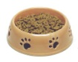](http://images.google.com.tr/imgres?imgurl=http://www.cheamviewvet.com/images/dog%20dish.jpg&imgrefurl=http://www.cheamviewvet.com/Prescription%20Diets.htm&usg=__8QngIwz-jMs5_eSDgZVR63wR4to=&h=396&w=500&sz=44&hl=tr&start=2&um=1&itbs=1&tbnid=XNBJRdSbVHGUfM:&tbnh=103&tbnw=130&prev=/images?q=dog+dish&um=1&hl=tr&tbs=isch:1) We have got a house. This is \_\_\_\_\_\_\_\_\_\_\_\_ house.

Puppy is a dog. This is \_\_\_\_\_\_\_\_\_\_\_ dish.

[https://www.HangiSoru.com](https://www.HangiSoru.com/)

1. **Aşağıdaki aktivitelerin isimlerini yazın. (2 pts each)**

**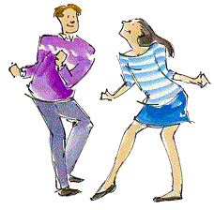**

[**https://www.HangiSoru.com**](https://www.HangiSoru.com/)****

****

****

Bahar alaçiçek

Englısh teacher