**1. Alice: My son has a cold.**

**Mary: He ……………… stay in bed and rest.**

a) is b) does c) should d) has

**2. Cem: I have a sore throat.**

**Aylin: …………………………………………….**

a) You shouldn’t carry heavy things.

b) You should use a plaster

c) You shouldn’t drink cold water

d) You shouldn’t watch Tv

**3. Cengiz: What is the matter ……… your father.**

**Mert: He …………………… a backache.**

a) at / is b) for / can

c) on / does d) with / has

**4. Deniz: ……………… does Ece get up?**

**Ferit: ………… six o’clock.**

a) What / On b) Where / On

c) What time / At d) How many / At

**5.** 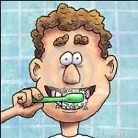 ***I …………… in the morming and at night.***

a) have a shower b) get up

c) brush my teeth d) study English

**6. Elif: …………… is the post office?**

**Beren: Go straight ……… and turn right.**

a) When / up b) How / down

c) Where / ahead d) What / past

**7. Laura likes …………… in her free time and she is at the …………………… now.**

a) swimming / bakery b) walking / bank

c) sleeping / chemist’s d) reading / library

**8. Suzan: …………………………………?**

**Melih: She is American.**

a) Where is Lucy from b) How old is Lucy

c) When is her birthday d) What nationality is Lucy

**9**.

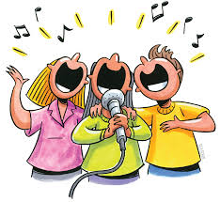

a) singing and dancing b) playing volleyball

c) going camping d) fishing

**10.** **We like playing …………………… man’s buff.**

a) blind b) art c) book d) good

**11. I am bored. Let’s play ……………………………**

a) board b) drawing c) checkers d) music

**12. 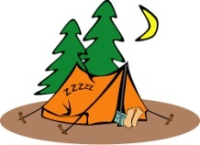 My sister has a hobby. She likes ……………………………………**

a) playing chess b) camping

c) taking photos d) reading book

**13. Ayla: ………… you play the piano?**

**Berk: No, but my sister …………… .**

a) Are / is b) Do / don’t

c) Does / do d) Can / can

**14. Aşağıdaki kelimeler gruplandırıldığında hangisi bu grubun dışında kalır?**

a) headache b) pain-killer c) earache d) backache

**15**. 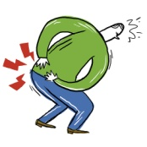 **I have a backache. .....................**

a) I should work hard

b) I shouldn’t carry heavy things

c) I need a plaster

d) I like dancing

G. Seçeneklerdeki yanlış şıkkı seçiniz.

(5*2=10 pts)

**1.** a) go – to school

b) play – television

c) listen – to music

**2.** a) have – a rest

b) get - dressed

c) do – chess

**3.** a) Maths - subject

b) checkers – food

c) hopscotch – game

**4.** a) skip – rope

b) draw – a Picture

c) listen – puzzle

**5.** a) cut – on my finger

b) see – a doctor

c) throat - ache

derskitabicevaplarim.com