**5-2 QUIZ NAME:**

derskitabicevaplarim.com

**A. Aşağıdaki kelimeleri sembolleriyle eleştiriniz. (5x2=10p)**

1 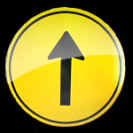 2. 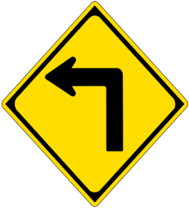 3. 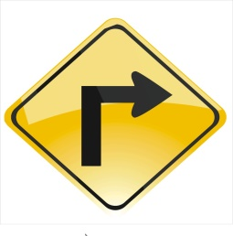 4. 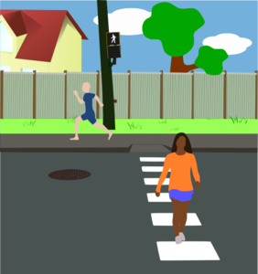 5. 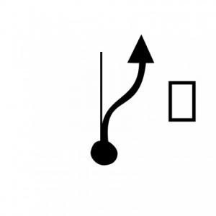

_________ _______ _______ _________ ________

1. Go straight ahead.
2. Cross the street.
3. Turn left.
4. It’s on your right.
5. Turn right.

**B. Tarif edilen yeri yazınız. (3*5=15)**

Go straight ahead. Turn left. Go straight ahead. It is opposite the cinema.

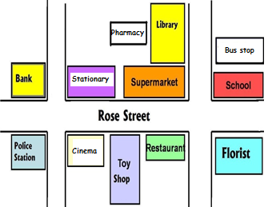

Go straight ahead. Cross the street. Go straight ahead. It is behind the library.

Go straight ahead. Turn right. It is on your left.

1. **Zarfları doğru resmin altına yazınız.(5x3=15)**

(**IN FRONT OF –BEHIND – NEAR – NEXT TO – BETWEEN )**

**1 2 3 4 5**

**……………………. …………………… ……………………. …………………. ……………….**

**D) Kelimeleri resimlerin altına yazınız. (20x3=60 points)**

|  |
| --- |
| **toy shop – supermarket – cafe - school – hospital – cinema – park – bank –**  **police station - chemist - car park - bakery - library - barber - florist**  **greengrocery - bus stop - hotel - mosque - post office** |

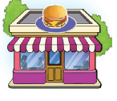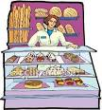  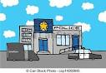 

………………………….. ……………………………. ……………………………………. …………………………………. ………………..

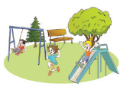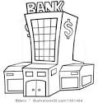 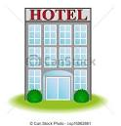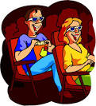 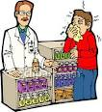

………………………… ……………………. ……………………………….. ………………………………… ……………………………

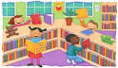 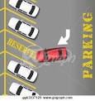 [](http://www.google.com.tr/url?sa=i&rct=j&q=&esrc=s&source=images&cd=&cad=rja&uact=8&ved=0ahUKEwivrvLhwqPQAhVFXhoKHZalAnIQjRwIBw&url=http://www.fotosearch.com/CSP994/k15801720/&bvm=bv.138493631,d.ZGg&psig=AFQjCNE9bULI4qV4ieKOibO7l3DytrFEyg&ust=1479050519754613)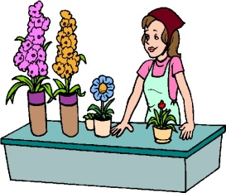

……………………….. ……………………………. ……………………………. ……………………………… ………………………..

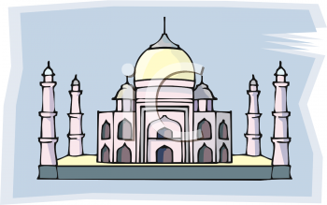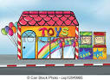 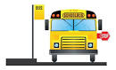 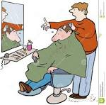 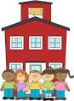

……………………………… ………………………………. ……………………………… …………………………… ……………………………….

Z.S. AKIN