**Name : Surname :**

**2017-2018 EDUCATION YEAR MALTEPE ÇÖZÜM**

**SECONDARY SCHOOL 2nd TERM 3rd QUIZ FOR 5th GRADE**

1. **Write fitness under their pictures. (10x2=20 pts.)**

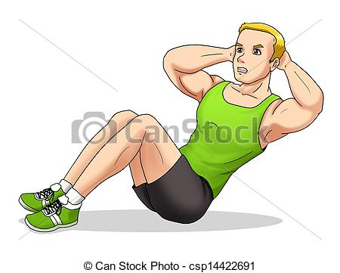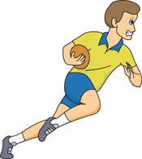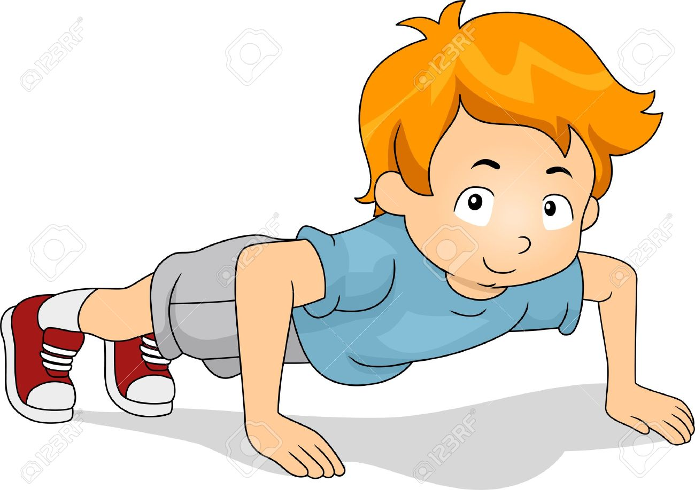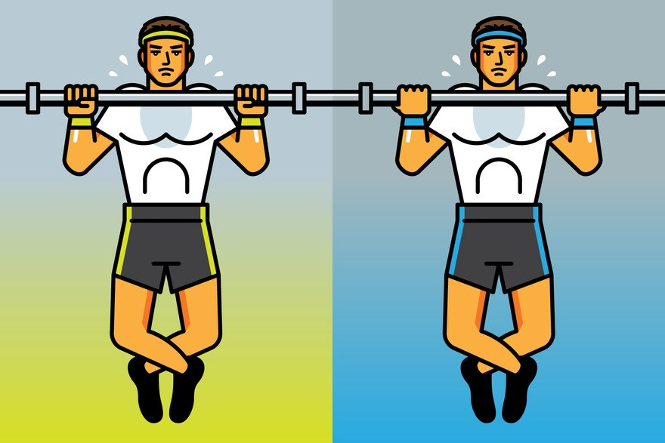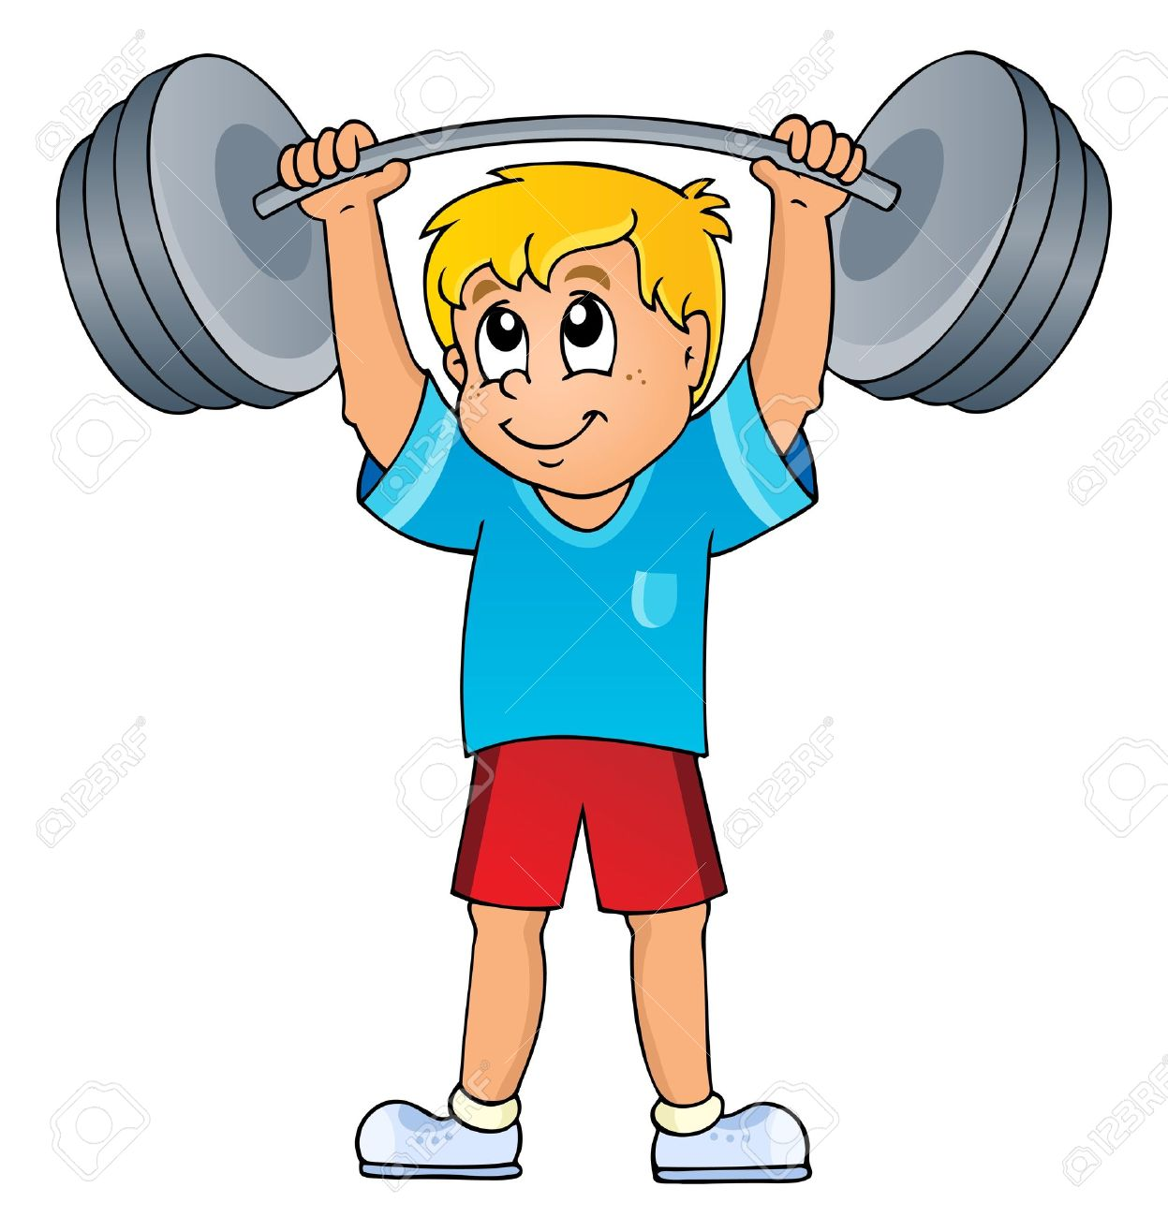

**………………. ………………. …………….. ……………. ………………..**

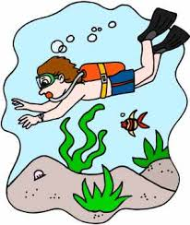 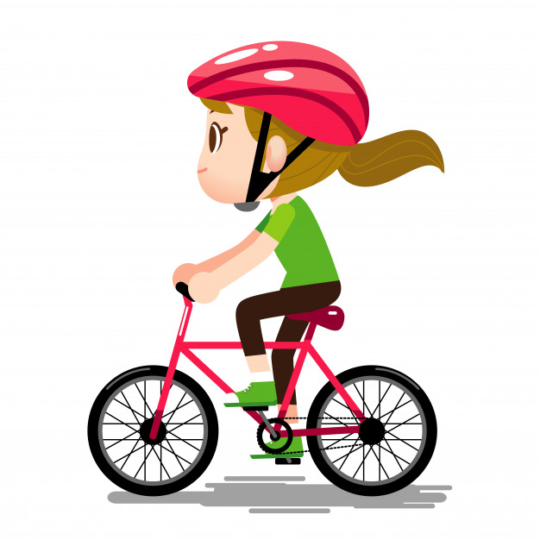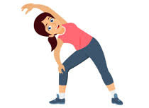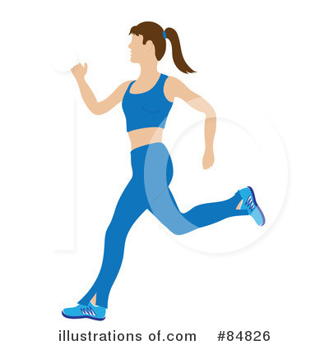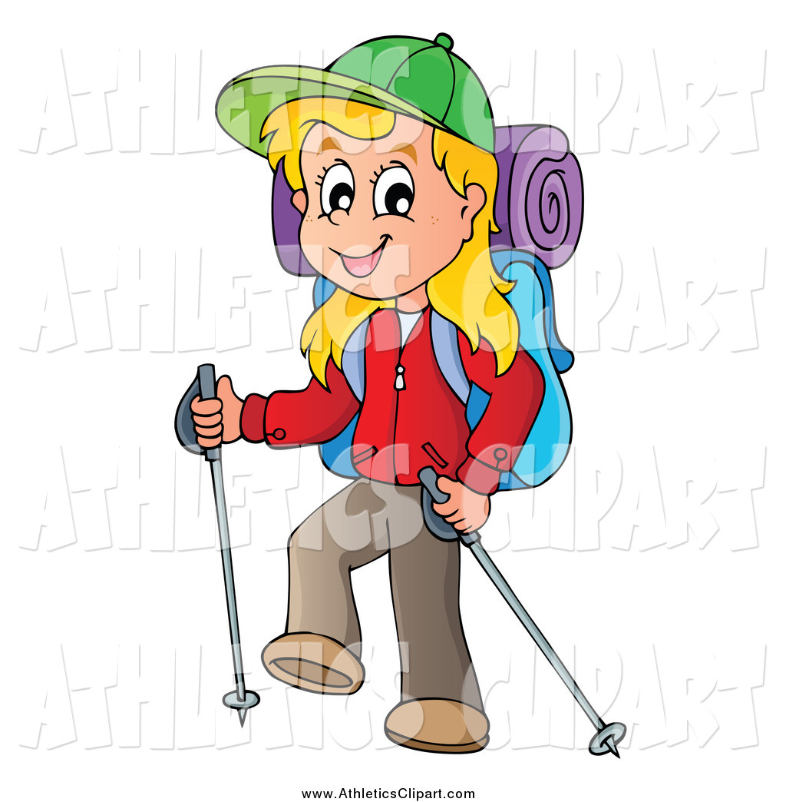

**…………… ………………….. ……………….. …………………. ……………..**

**B .Read the passage and write T (True) or F (False). (6x3=18pts.)**

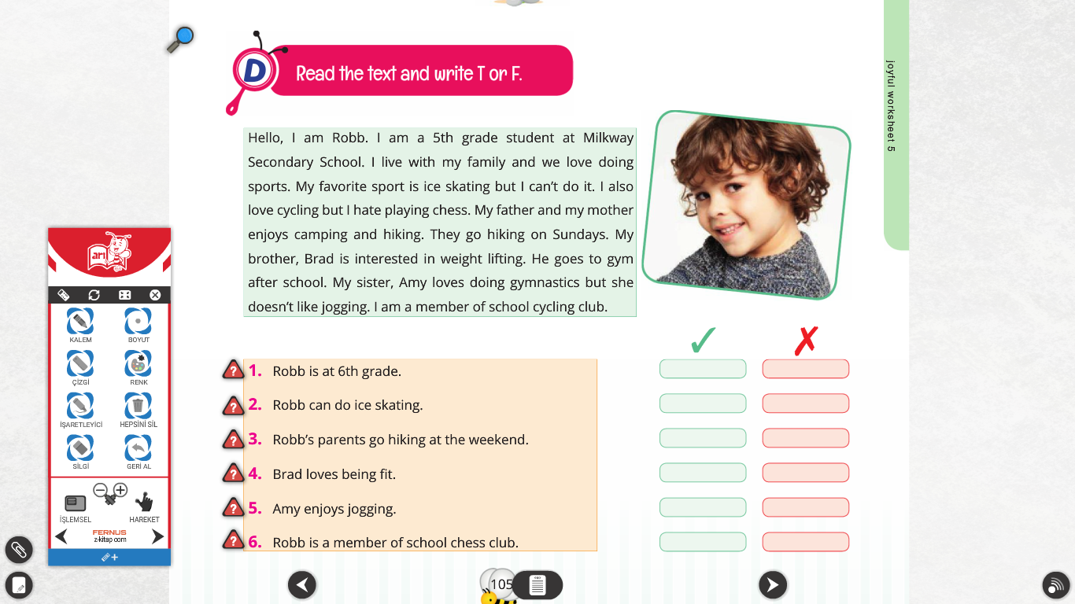

**C )Fill in the blanks with the words in the box . (8x2=16 pts.)**

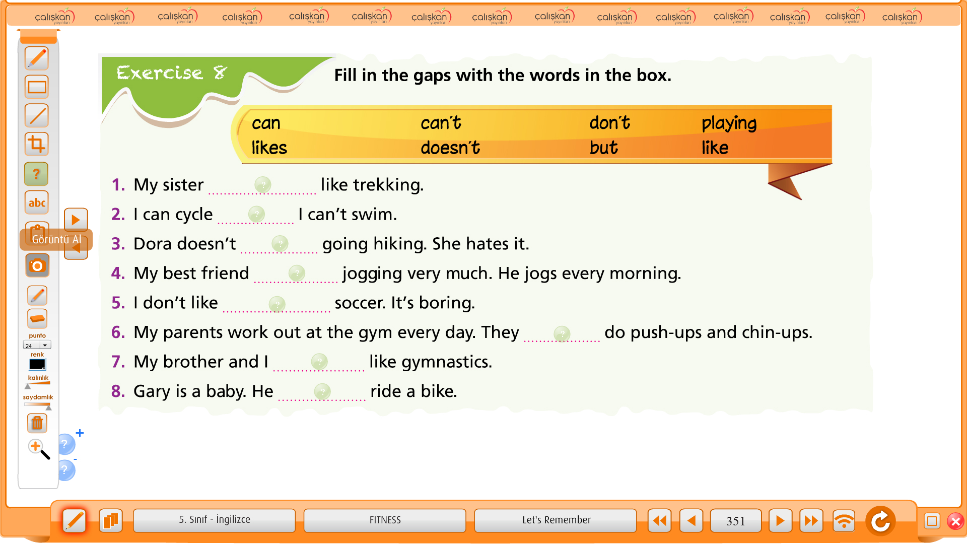

**D)Fill in the blanks with “Let’s ,Shall we ,How about” (5x2=10 pts.)**

1) …………. go swimming this afternoon.

2) ……………. sleeping in the tent tonight?

3) …………….. working out in the gym?

4) …………… go windsurfing?

5) ………… go to the cinema.

**E )Choose true answer. (5x2=10pts.)**

1) Hi Lee! …………. going to the beach tomorrow?

A) How about B) let’s C) Shall we

2) Let's ____ to the beach tomorrow. It's going to be too hot.

A) to go B) going C) go

3) ____ going to the movies?

A) How about B) let’s C) Shall we

4) Good idea Sam!  ___ invite Mark to go with us!

A) How about B) Let's C) Shall

5) Hi Mark. We're going to the movies tomorrow. ……….. to come with us?

A) Shall we B) Let ‘s C) Would you like

**F )Answer the questions about yourself . (8x2=16 pts.)**

1)What is your favourite exercise ? 5)Do you like playing baseball ?

…………………………………… …………………………………….

2)Do you like cycling ? 6)Can your english teacher run twenty kilometres ?

…………………………………. ……..……………………………

3)What fitness activity do you like ? 7)Can you play table tennis ?

……………………………………. …………………..………………………..

4)Can you do push –up ? 8)Can you do karate ?

………………………………… ………….……………………………

**G.Write synonyms (5x2=10pts.)**

1. **Be form : ………………….** derskitabicevaplarim.com
2. **Hiking : …………………….**
3. **Football : ………………….**
4. **Do work out : ………………………..**
5. **Ride a bike : …………………** English Teacher Miss. KIRMACI