**VERİLEN RESİMLERE BAKARAK UYGUN SIFATLARI KULLANIN**

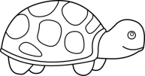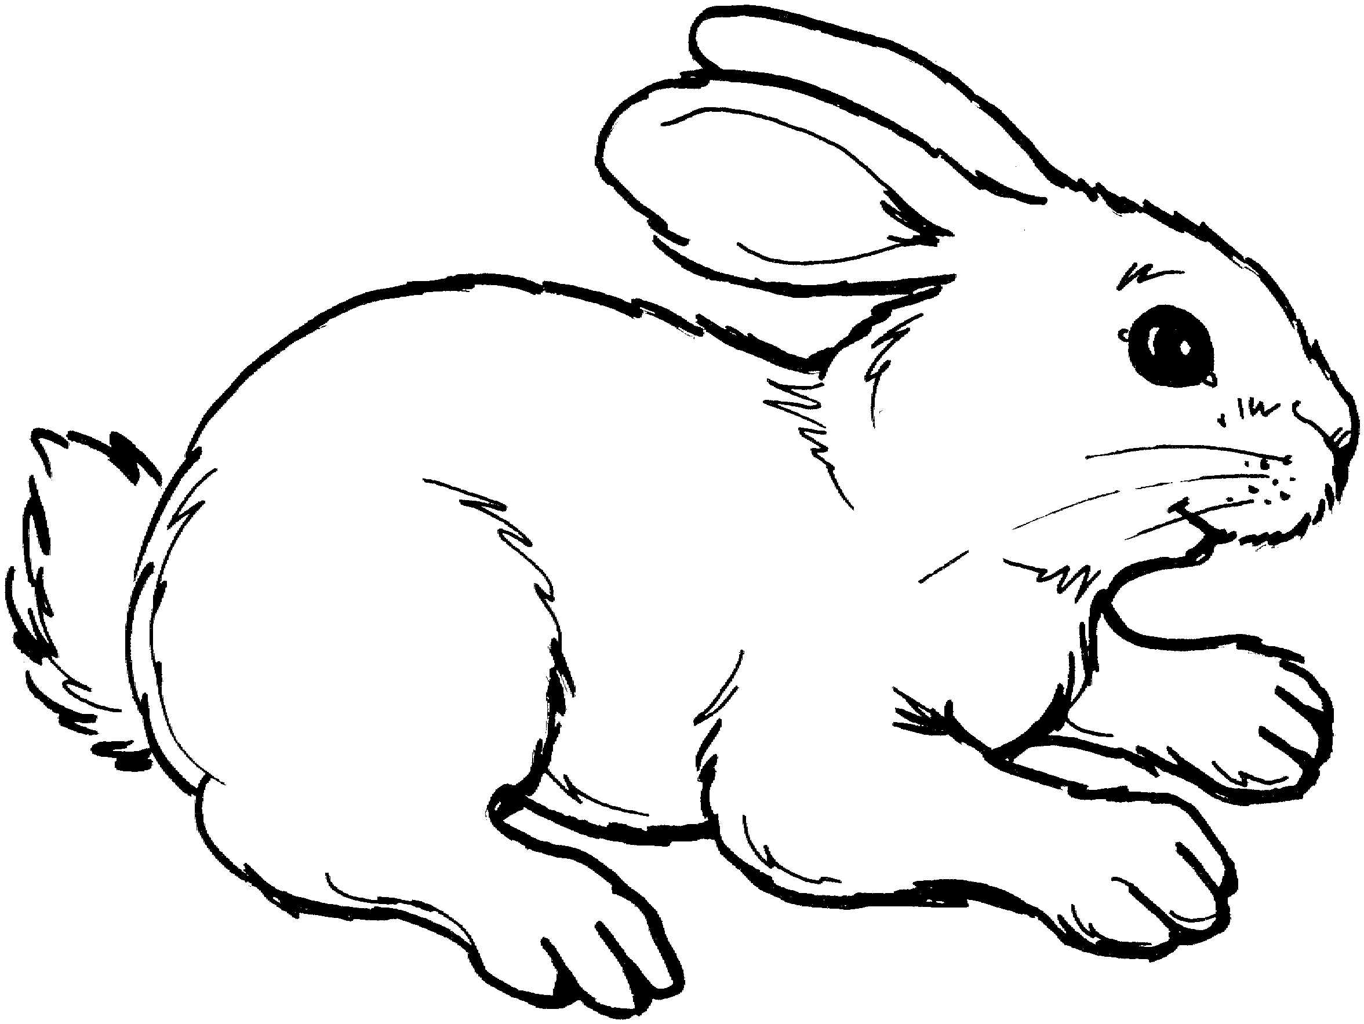

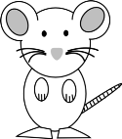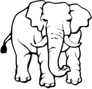 -------------------------------- -------------------------------------

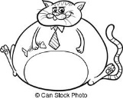-------------------------------------- ----------------------------------------

--------------------------------- -----------------------------------------

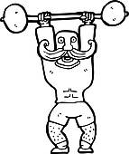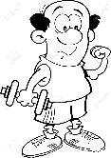

-------------------------------------- -------------------------------------------

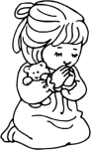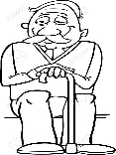

------------------------------------------ --------------------------------------------

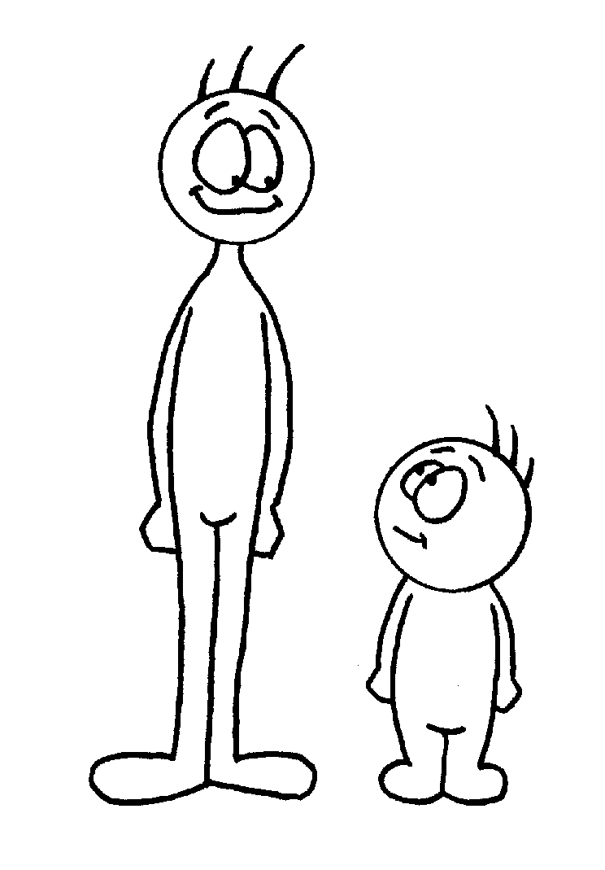

----- ---------------------- ----------------------------

**SORULARA İSTENİLEN CEVAPLARI VERİN.**



IS HE STRONGSTRONG?

IS HE WEAK?

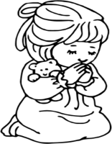

IS SHE YOUNG?

IS SHE OLD?

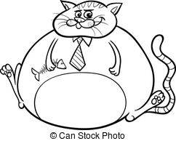

IS ITHEAVY?

IS ITTHIN?



IS ITBIG?



IS ITFAST?

IS ITSLOW?

IS ITSMALL?

**VERİLEN RESİMLERİ CAN / CAN’T İLE TAMAMLAYIN.**

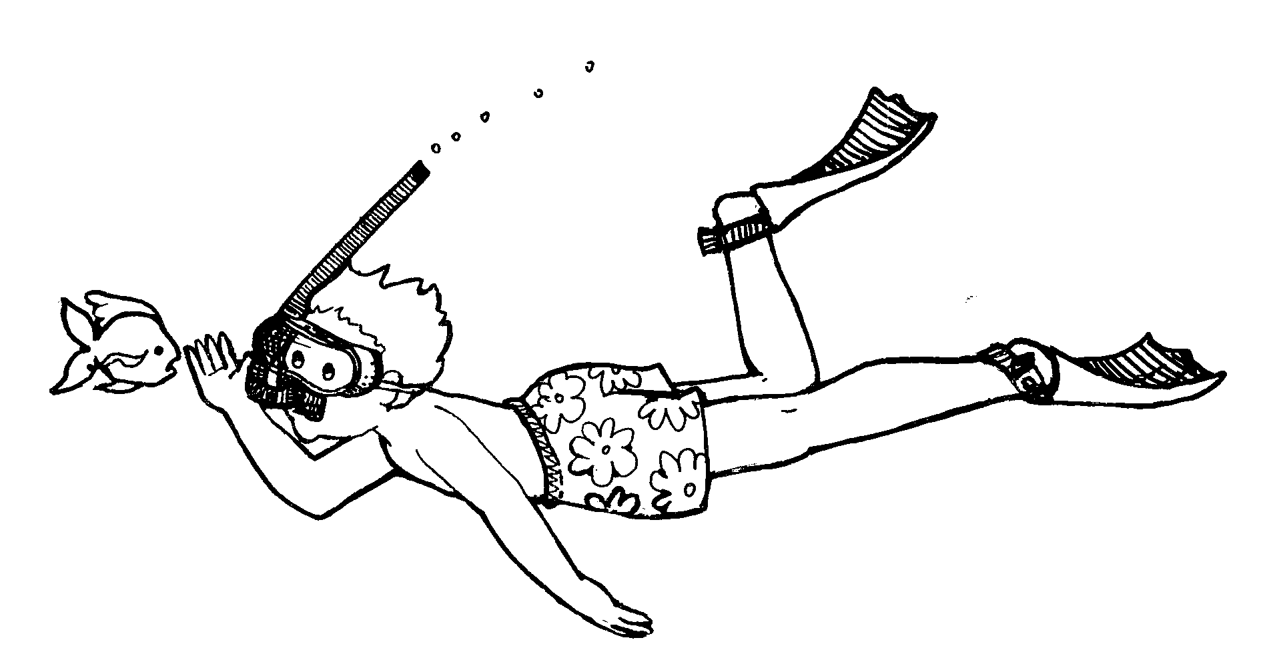 (+)-------------------------------------------------

(-)………………………………………………………..

(?)………………………………………………………..……………………………………………….............

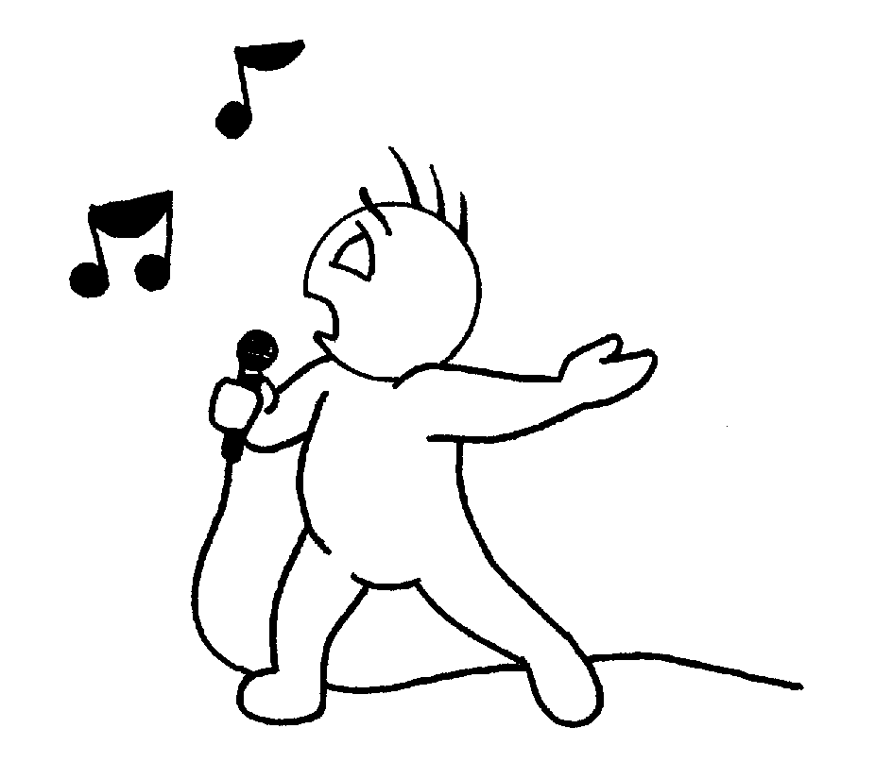(+)-------------------------------------------------

(-)………………………………………………………..

(?)………………………………………………………..……………………………………………….............

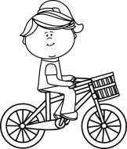

(+)-------------------------------------------------

(-)………………………………………………………..

(?)………………………………………………………..……………………………………………….............

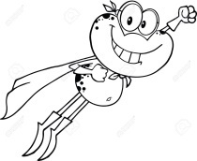(+)-------------------------------------------------

(-)………………………………………………………..

(?)………………………………………………………..……………………………………………….............

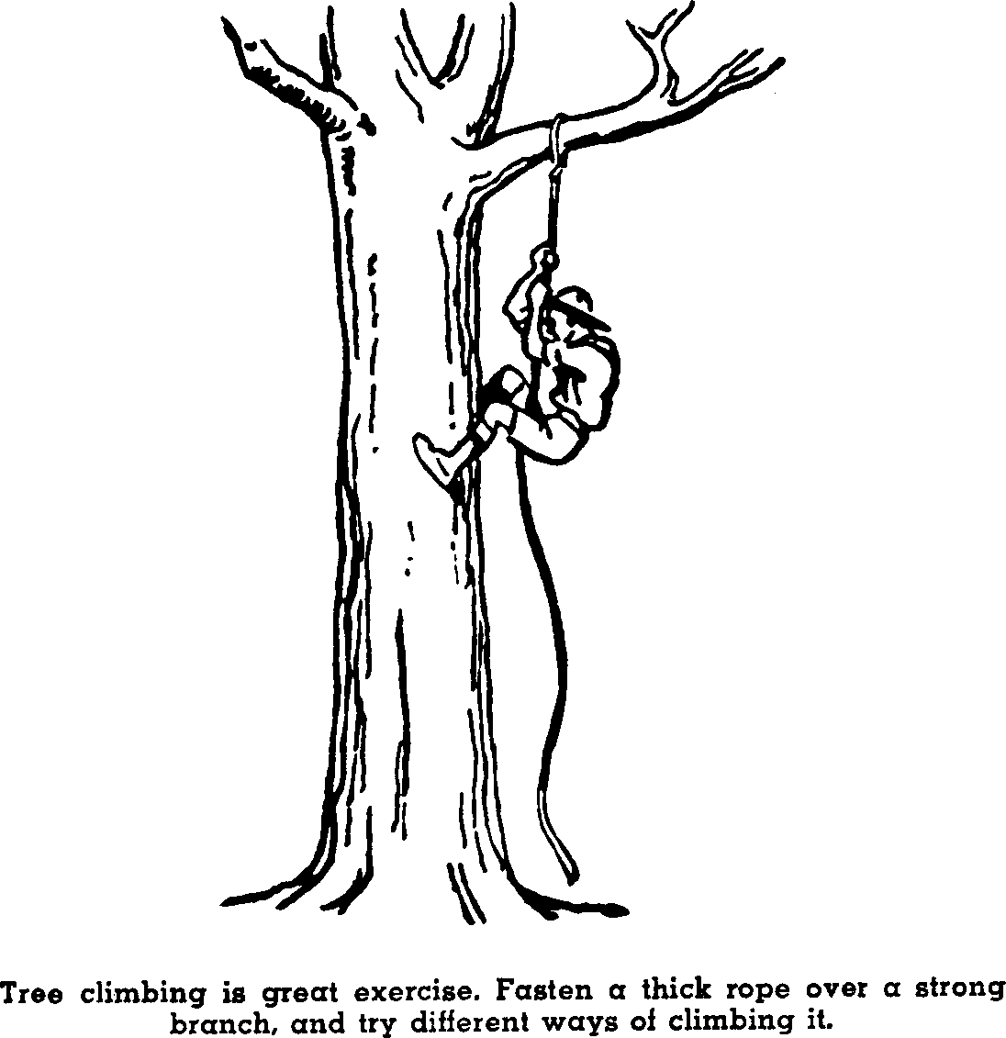

(+)-------------------------------------------------

(-)………………………………………………………..

(?)………………………………………………………..……………………………………………….............

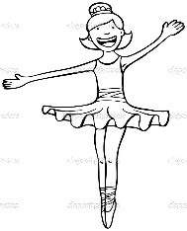

(+)-------------------------------------------------

(-)………………………………………………………..

(?)………………………………………………………..……………………………………………….............

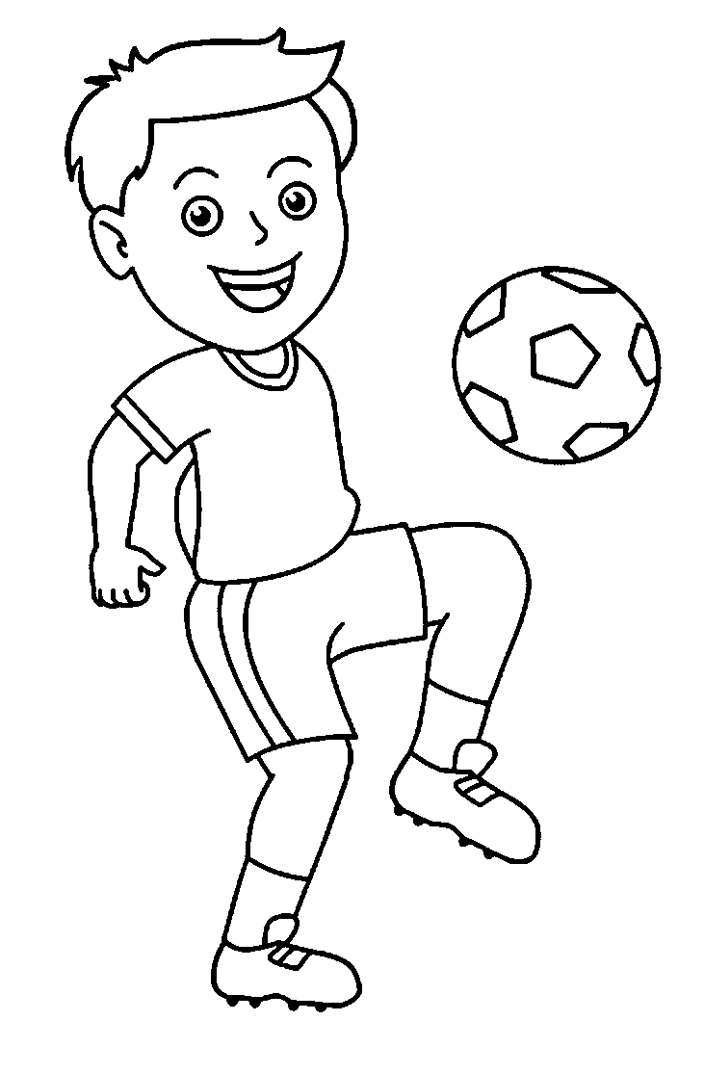

(+)-------------------------------------------------

(-)………………………………………………………..

(?)………………………………………………………..……………………………………………….............

[www.HangiSoru.Com](http://www.HangiSoru.com/)