SUNNY ( güneşli ) | RAINY ( yağmurlu )
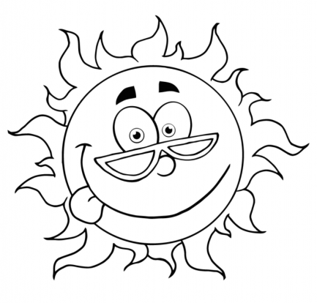 | 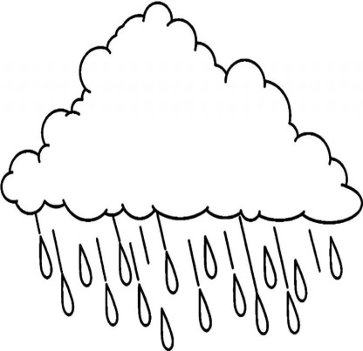
SNOWY ( karlı ) | WINDY ( rüzgarlı )
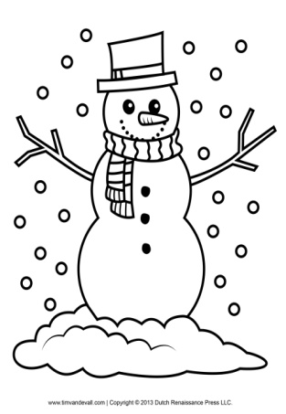 | 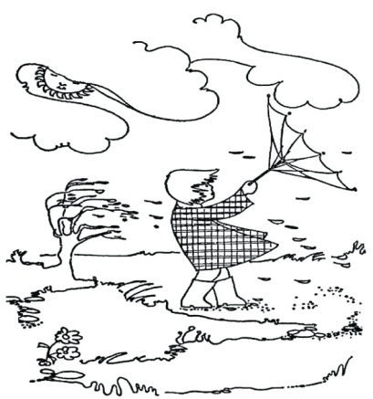

HOT ( sıcak ) | COLD ( soğuk )
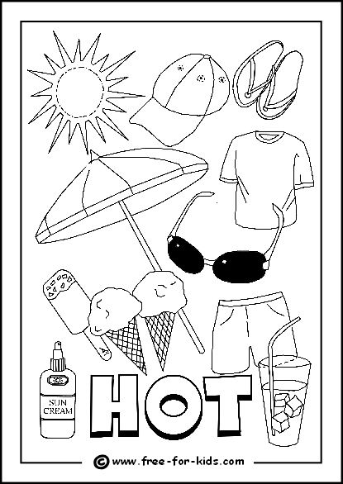 | 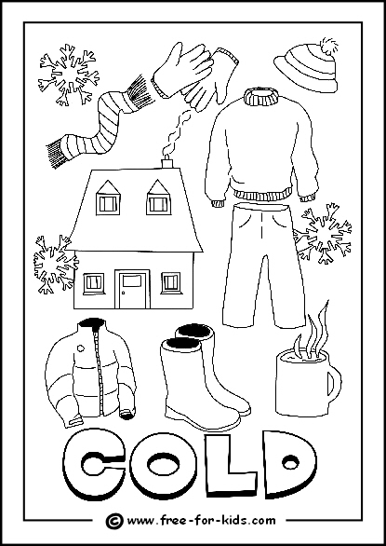

Greetings: selamlaşma | MY family : ailem | Adjectives: sıfatlar
1-) Bye : güle güle  2-) Good morning: günaydın  3-) teacher: öğretmen  4-) Good evening: iyi akşamlar  5-) Good night : iyi geceler  6-) Hello : merhaba  7-) Hi : selam  8-) See you : görüşürüz | 1-) Mother : anne  2-) Mom : anne  3-) Father :baba  4-) Dad: baba  5-) Grand mother: büyük anne  6-) Grand father : büyük baba  7-) Sister : kız kardeş  8-) Brother : erkek kardeş  9-) Cousin : kuzen  10-) Aunt : teyze, hala  11-) Uncle : amca | 1-) Beautiful : güzel  2-) Big : büyük  3-) Small : küçük  4-) Old: yaşlı  5-) Young : genç  6-) Fast : hızlı  7-) Slow: yavaş  8-) Tall : uzun  9-) Strong : güçlü
Feelings : duygular | Colors : renkler | My house : Evim
1-) Angry : sinirli  2-) Bad :kötü  3-) Drink : içmek  4-) Eat : yemek  5-) Good : iyi  6-) Go : gitmek  7-) Happy : mutlu  8-) Okay : tamam  9-) Read : okumak  10-) Sleep : uyumak  11-) Write : yazmak | 1-) Red: kırmızı  2-) Yellow: sarı  3-) White: beyaz  4-) Blue: mavi  5-) Green: yeşil  6-) Pink: pembe  7-) Brown: kahverengi  8-) Purple : mor | 1-) Room : oda  2-) Bed : yatak  3-) Bed-room : yatak odası  4-)Living-room : oturma odası  5-) Home: ev  6-) Armchair: koltuk  7-) Garden : bahçe  8-) Shampoo : şampuan
Vehicles : araçlar | Days : günler | My city: benim şehrim
1-) Bike: bisiklet  2-) Boat : bot  3-) Bus : otobüs  4-) Car :araba  5) Plane: uçak  6-) Helicopter: helikopter  7-) Ship : gemi  8-) Motorcycle: motor  9-) Taxi : taksi  10-) Train: tren  11-) Ambulance :ambulans | 1-) Monday : pazartesi  2-) Tuesday : Salı  3-)Wednesday: Çarşamba  4-) Thursday : Perşembe  5-) Friday : Cuma  6-) Saturday: cumartesi  7-) Sunday : Pazar | 1-) Bank : banka  2-) Cafe : kafe  3-) Cinema: sinema  4-) Hospital: hastane  5-) Market : market  6-) Mosque: cami  7-) Park : park  8-) Restaurant : restorant  9-) School: okul
 | Weather : hava
1-) Cold: soğuk
2-) Hot: sıcak
3-) Rainy : yağmurlu
4-) Sunny : güneşli
5-) Snowy : karlı
6-) Windy : rüzgarlı
7-) Warm : ılık
8-)Wet : ıslak

https://www.HangiSoru.com

