**YARDIMA İHTİYACIM VAR**

[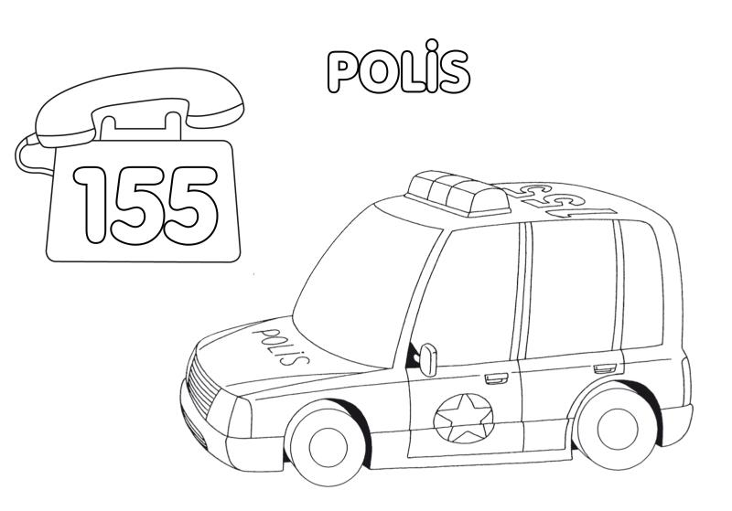](http://www.google.com.tr/url?sa=i&rct=j&q=&esrc=s&frm=1&source=images&cd=&cad=rja&docid=nX6q9fqFtPN4_M&tbnid=E7btmA9rDxP_VM:&ved=0CAUQjRw&url=http://www.onceokuloncesi.com/grafik-ornekleri/acil-durumlar-icin-telefon-grafigi-79711.html&ei=2Kh2Us7_B4WStAaZ4YCQDA&bvm=bv.55819444,d.bGE&psig=AFQjCNER_nreWhNS_GJqASIBXznHomcY4g&ust=1383594297085578)[www.HangiSoru.com](http://www.HangiSoru.com/)

[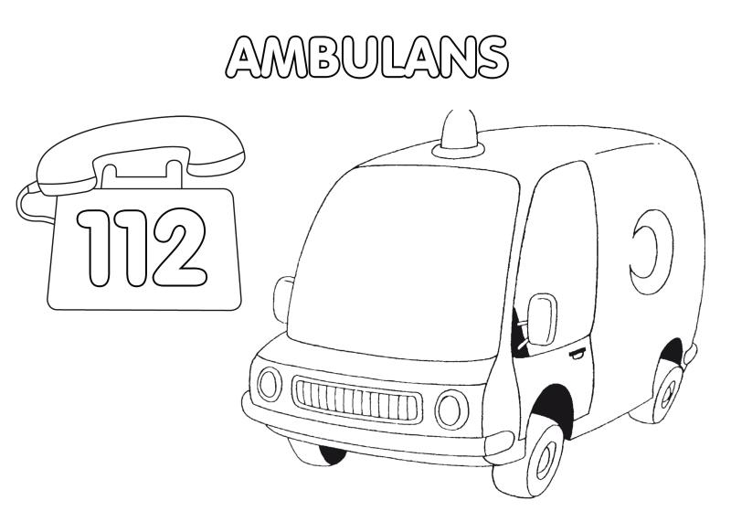](http://www.google.com.tr/url?sa=i&rct=j&q=&esrc=s&frm=1&source=images&cd=&cad=rja&docid=nX6q9fqFtPN4_M&tbnid=mHDLV0KPVJ9ENM:&ved=0CAUQjRw&url=http://www.onceokuloncesi.com/grafik-ornekleri/acil-durumlar-icin-telefon-grafigi-79711.html&ei=Gqp2UuafHsjBtQbv2oGQDg&psig=AFQjCNH2mG5uZkZu8quJiSJJRCHsgL1MBA&ust=1383594734166656)

