derskitabicevaplarim.com
Board Ruler Book Paper
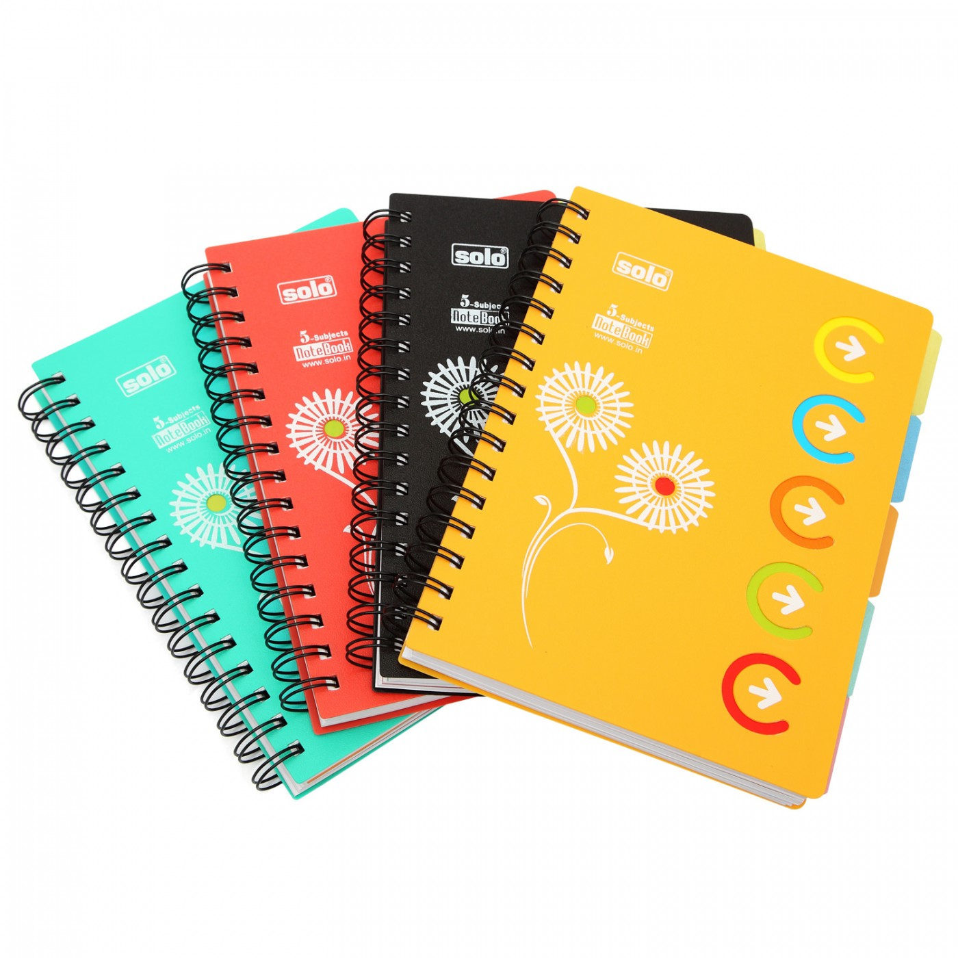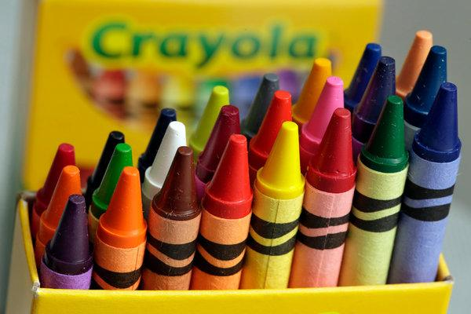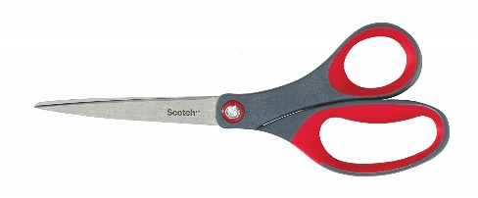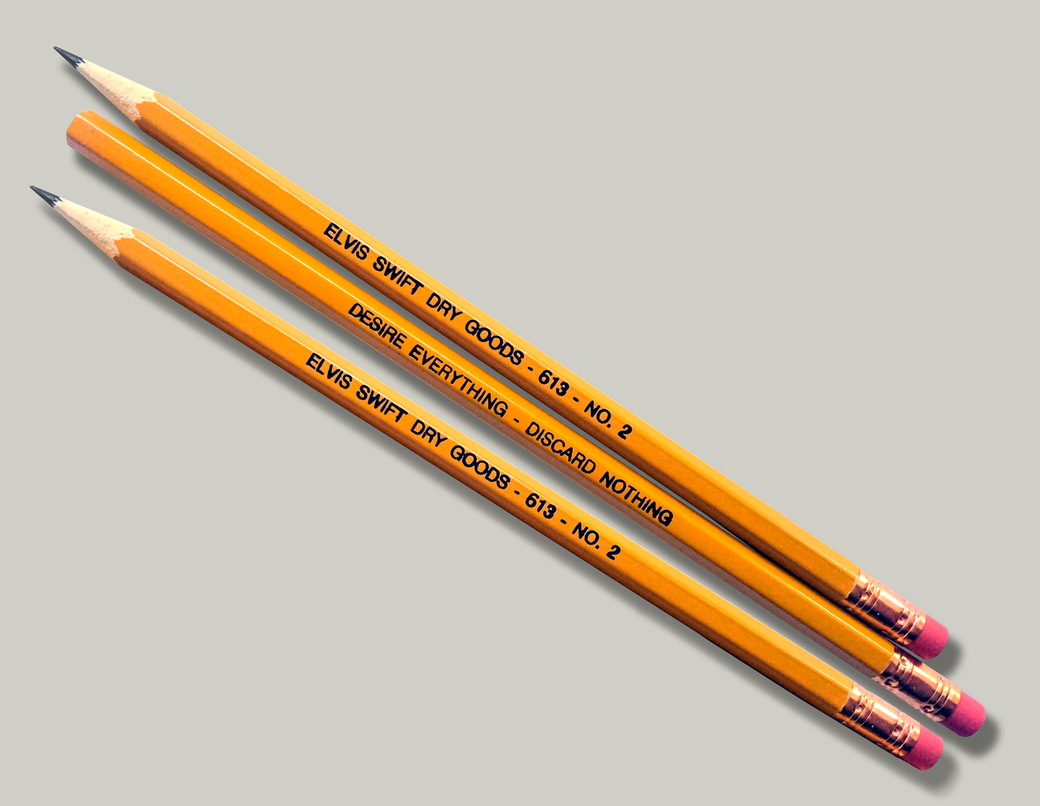
Notebook Crayon scissory pencill
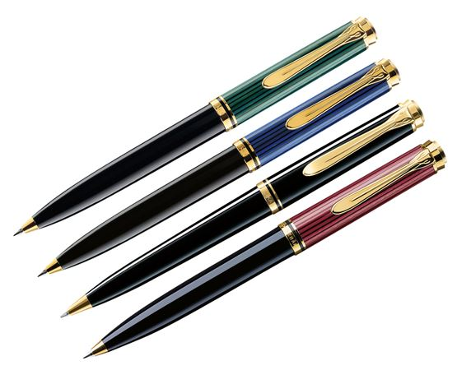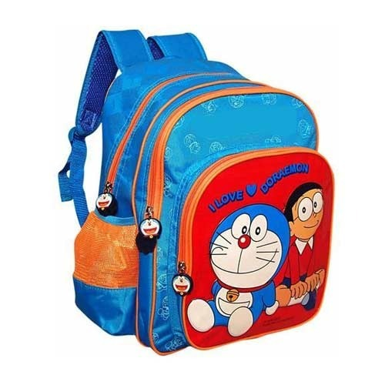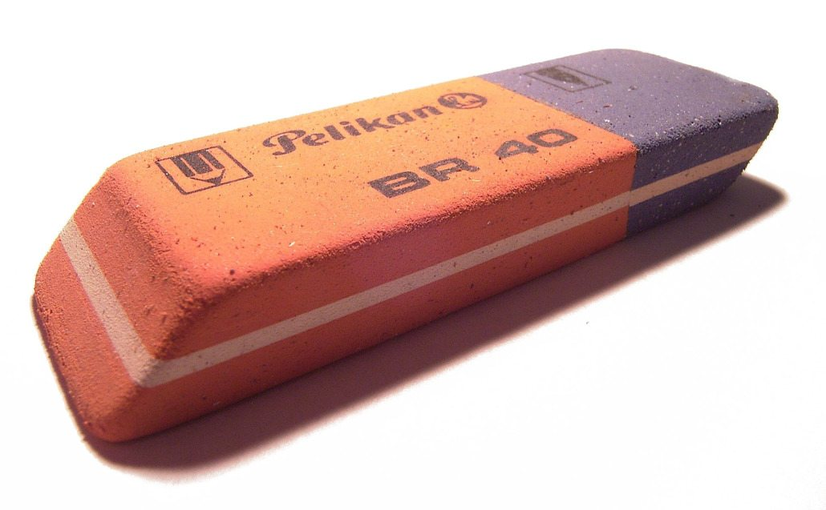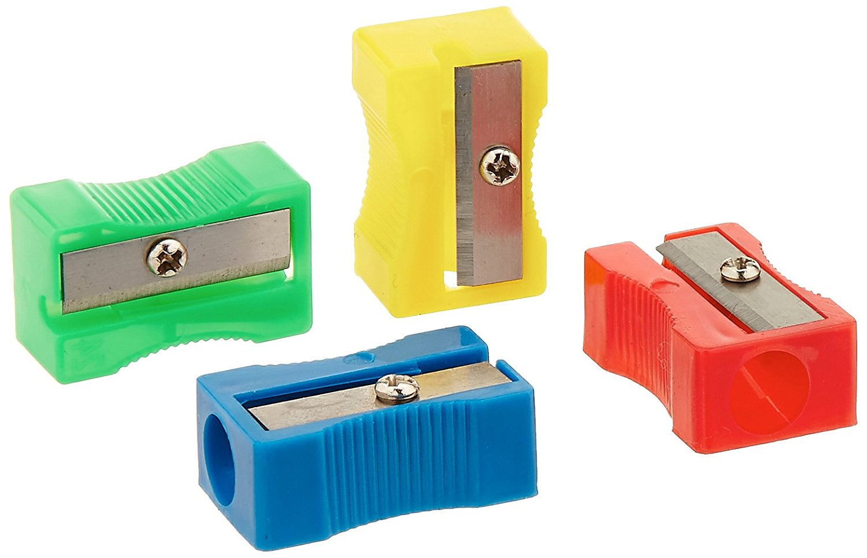
Pen School bag Eraser Pencillsharpener

How oldareyou? I’m eight.
Kaç yaşındasın? Ben sekizim.
How many? (Kaç tane?)
1 2 3 4 5 6 7 8 9 10
OneTwoThree FourFiveSix Seven EightNine Ten

