Name :
Surname:
Class :
Number :
True
Doğru:
False
Yanlış :

I am Spanish.
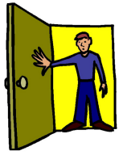
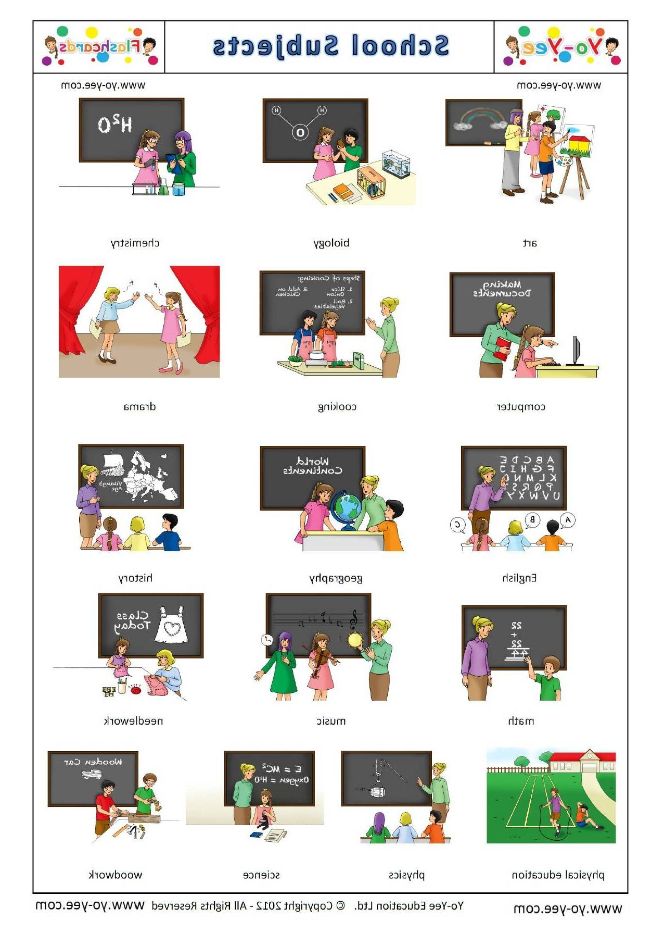
1
6
May I ............. in ?
Yes you may .

A) come
B) close
C) turn
D) write

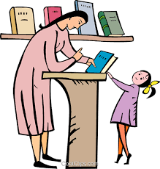
2
________ .
Give me the book,please !
________ .
Give me the book,please !

A) Excuse me.
B) Here you are.
C) Stand up.
D) Not right now .

3
Aşağıda verilen sayıların hangisinin yazımı
yanlıştır ?

A) 77-seventy-seven B) 81 – eighty-one
C) 56 – fivety - six D) 100 – one hundred

4
Görseli ifade eden seçenek aşağıdakiler-
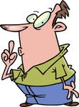
den hangisidir ?

A) Please,come in.
B) Look at the board.
C) Be quiet.
D) Say that again,please.

5
Is she from India ?
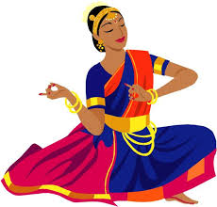
A) Yes,he is.
B) Yes,she is.
C) No,he isn’t.
D) No,she isn’t.
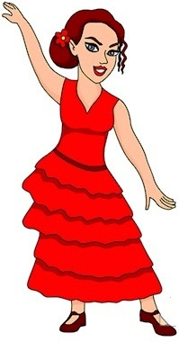
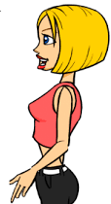
…………..

Yukarıdaki konuşmayı tamamlyan seçenek hangisidir ?

A) What is your name ?
B) Where is she from ?
C) Is he Spanish ?
D) What is your nationality ?
7
Is he Russian ? sorusuna verilebilecek
olumlu cevap hangisidir ?

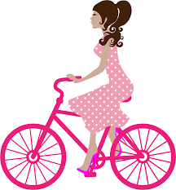
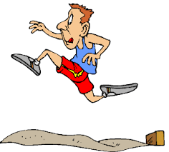
A) I don’t think so. B ) Yes,she is.
C) No,he isn’t. D) I think so.
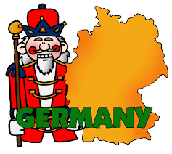
8
Efe : Where is Germany ?
Ela : It is……………….. .

A) Asia B) Africa
C) Europe D) America
9
A: I like playing football.
B: ……………………….
A: I like playing football.

A) Thank you. B) Pardon ?
C) I think so. D) That’s right.
10
Seçeneklerden hangisi boşluğa getirilemez ?
play
football
chess
………….
tennis

A) volleyball
B) the guitar
C) basketball
D) kite
Görseli ifade eden seçeneği bulunuz .
11

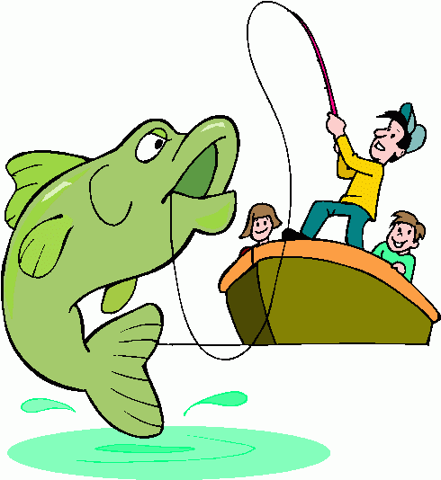
A) I like fishing.
B) I like swimming.
C) I like riding
D) I like climbing

12
" I like riding a bike " cümlesini söyleyen
çocuk aşağıdaki resimlerden hangisinde
yer almaktadır ?
A) B) C) D)
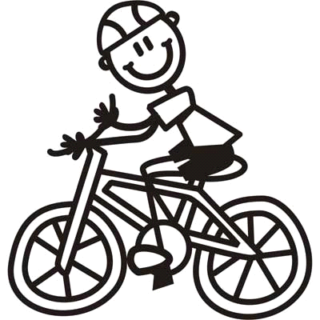
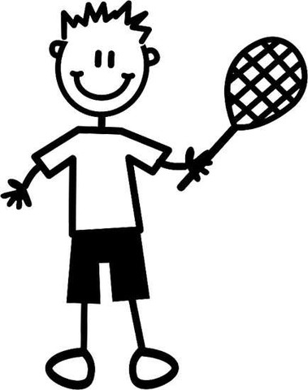
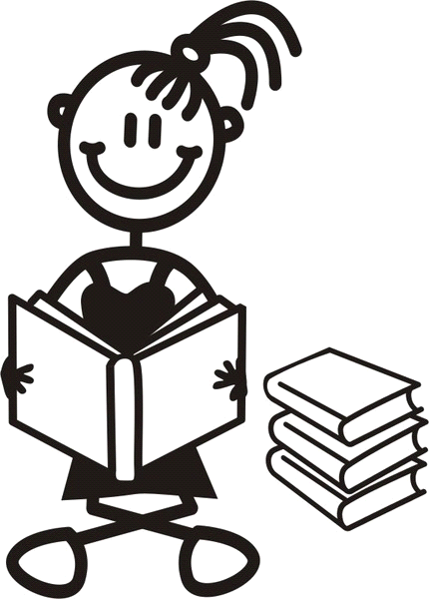
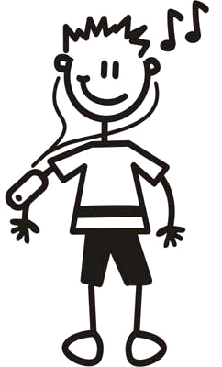

13

This is…………… ball.
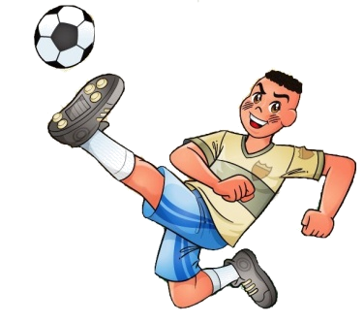
He can play football.

A) my
B) his
C) your
D) her
14
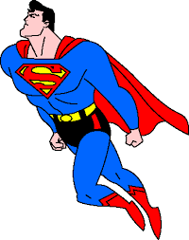
Burcu : My hero is Superman .
Şaban : Your hero can……….?
Burcu : Yes,he can.

A) dive B) cook
C) sing D) fly

15
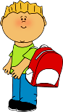
Doğru seçeneği işaretleyiniz.

………………

A) This is my bike and I can ride it .
B) This is my horse and I can ride it .
C) This is my bag and I can carry it .
D) This is my guitar and I can play it.

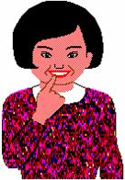
16
I like………….cartoons.
A) watching
B) reading
C) playing
D) diving

17
Konuşmayı tamamlayan etkinlik hangisidir?
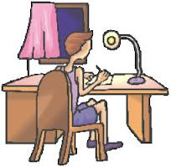
I do my ...........

A) the guitar B) homework
C) puzzles D) pictures
18
What time is it ?

A) half past twelwe.
12:50
B) twelwe fifty.
C) twelve o'clock.
D) quarter past twelve.
19

Konuşmada boş bırakılan yere ; uygun
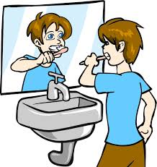
düşen ifadeyi bulunuz.
I ……………..

A) I wash my hand.
B) I comb my hair.
C) I brush my teeth.
D) I get undressed.

20
“ I meet my friends in the afternoon.

Cümlesini anlatan resim hangi seçenekte verilmiştir ?

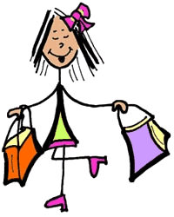
A) B)

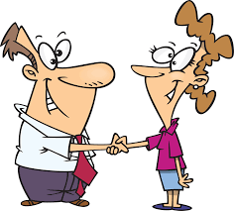
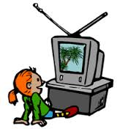

C) D)
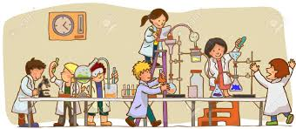
21

Students are in the……………

A) classroom B) home
C) laboratory D) school
22
What is " experiment " in Turkish ?

A) koruyucu gözlük B) deney
C) mikroskop D) saksı

23
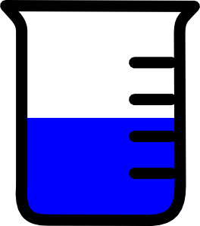
Where is the container ?
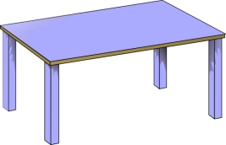
A) It is behind the table.
B) It is under the table.
C) It is in front of the table.
D) It is in the table.
24
Aşağıda verilen resim - kelime eşleştirmele-

rinden hangisi yanlıştır ?

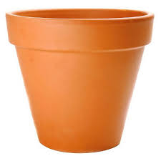

A) microscope B) pot
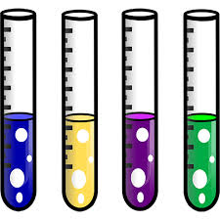
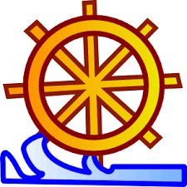

C) tube D) goggles

25
A: ………………........ .
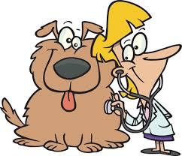
B:He is a vet.

A) What can she do ?
B) What does he likes ?
C) Where does he work?
D) What is his job ?
Verilen resme göre doğru seçeneği işaret-
26
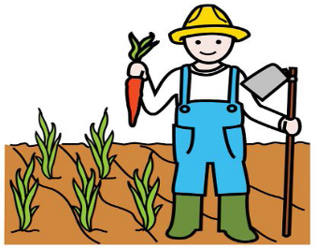
leyiniz.

A) Writer
B) Mechanic
C) Farmer
D) Plumber

27
My father is a pilot.He likes…………… .
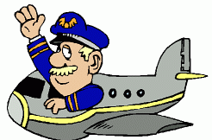
A) sailing
B) singing
C) flying
D) driving

28
............. works at a company.


A) A policeman
B) A doctor
C) A teacher
D) A businessman

29

Choose the correct one.
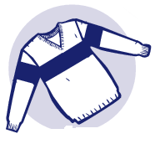
A) sweater
B) pants
C) tie
D) T-shirt

30
May I ..............your umbrella ?


A) wear
B) borrow
C) put
D) like

It is cold and snowy in ................. .
31

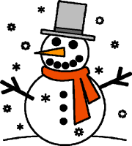
A) summer
B) spring
C) winter
D) autumn

32
How's the weather ?
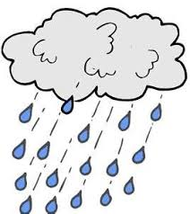

A) It's windy.
B) It's rainy.
C) It's foggy.
D) It's snowy.

33

Ali is very…………. . He helps old people.

A) rude B) lazy
C) helpful D) hardworking.

34
Aşağıdaki ifadeler gruplandırıldığında han-
dışarıda kalır ?

A) curly B) straight
C) wavy D) young

35
She is……………… ..
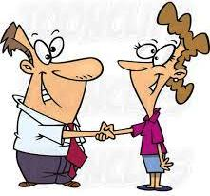
A) friendly
B) shy
C) old
D) rude

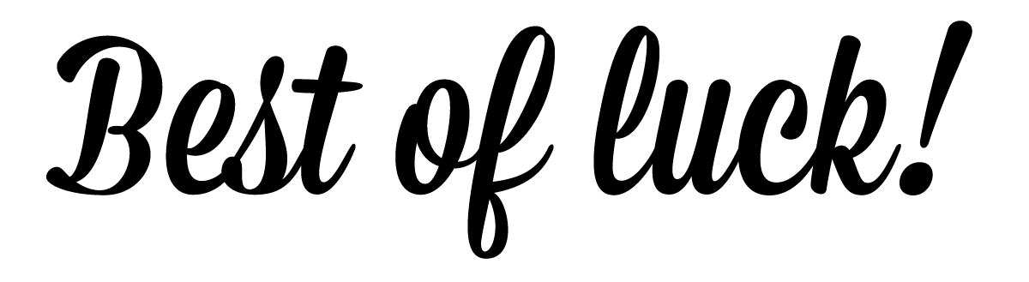
Metehan : ………………………… ?
36
Batuhan :He is polite and friendly.

A) What does he do ?
B) What is he like ?
C) What does he like ?
D) What does he look like ?

37
…………........... is a Mexican food.
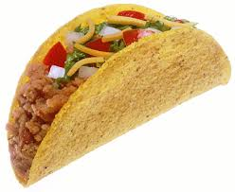
A) Taco
B) Kebab
C) Sushi
D) Pizza

38
Seçeneklerden hangisi " Belki daha sonra. "
anlamındadır ?

A) Thank you. B) Yes,of course.
C) Maybe later. D) Not now,thanks.

39

A:What about a drink with your hamburger?
B: Yes,………………………………………

A) I want some bread,please.
B) I’am full.
C) I want some doner kebab ,please.
D) I want some apple juice,please.

40
A: Are you hungry ?
B: Yes,I’am.
A: What do you want ?
B: I want a……………….

A) sandwich
B) tea
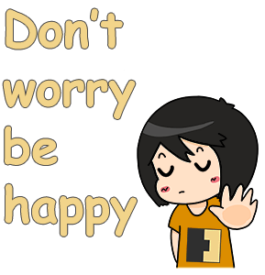
C) coffee
D) lemonade

